Computer Network
A computer network is a collection of interconnected devices that share resources and information. These devices can include computers, servers, printers, and other hardware. Think of it like a highway system for data, allowing information to travel from one point to another. Networks allow for the efficient exchange of data, enabling various applications such as email, file sharing, and internet browsing.

Basic Terminologies of Computer Networks
- Network: A group of connected computers and devices that can communicate and share data with each other.
- Latency: The time it takes for data to travel from its source to its destination.
- Bandwidth: The maximum amount of data that can be transmitted over a network connection or link at once, typically measured in bits per second (bps). Bandwidth itself is the capacity, not the speed at which the data travels.
- Throughput: The actual amount of data successfully transferred over a network, which is almost always lower than the total available bandwidth due to various factors.
- Node/Hosts/End Systems: Any device that can send, receive, or forward data in a network. This includes laptops, mobiles, printers, earbuds, servers, etc. Hosts are further divided into two categories: clients and servers.
- Network Edge: The computers and other devices connected to the Internet are referred to as end systems. They are referred to as end systems because they sit at the edge of the Internet. It involves access network and physical media.
- Networking Devices: Devices that manage and support networking functions. This includes routers, switches, hubs, and access points.
- Network Core: It refers to the component that provide services to endpoints, i.e. hosts. It involves interconnected routers. They are also referred to as network of networks. It involves packet/circuit switching.
- Transmission Media: The physical or wireless medium through which data travels between devices.
- Wired media: Ethernet cables, optical fiber.
- Wireless media: Wi-Fi (WLAN), Bluetooth, infrared, WWAN.
- Local Area Network (LAN): It links computers, servers, printers, and other devices within a localized area. Such as home, office, or campus. Its limited distance allows for high-speed data transfer and communication.
- Wide Area Network (WAN): A WAN acts as a network of networks, linking numerous LANs together to form a larger, interconnected system.
- Service Provider Networks: Networks offered by external providers that allow users or organizations to lease network access and capabilities. This includes internet providers, mobile carriers, etc.
- Internet standards: They are developed by the Internet Engineering Task Force (IETF). The IETF standards documents are called requests for comments (RFCs). They define protocols such as TCP, IP, HTTP (for the Web), and SMTP (for e-mail). There are currently nearly 9000 RFCs. Other bodies also specify standards for network components, most notably for network links. The IEEE 802 LAN Standards Committee, for example, specifies the Ethernet and wireless Wi-Fi standards.
- Switching: It is the process of transferring data packets from one device to another in a network or from one network to another, using specific devices called switches. There are 2 main types of switching methods, Circuit Switching & Packet Switching.
- Quality of Service (QoS): By prioritizing traffic based on defined policies, QoS ensures that critical data like voice calls or video conferences receive necessary resources such as bandwidth, while less time-sensitive traffic may experience delays.

The Network Edge

Access Network
The network that physically connects an end system to the first router (also known as the “edge router”) on a path from the end system to any other distant end system. An access network is the local portion of a telecommunications system that connects end-users (like your home or office) to the larger network, such as the Internet or a wide area network (WAN). Examples of access networks are ISP, home networks, enterprise networks, ADSL, mobile network, FTTH etc.

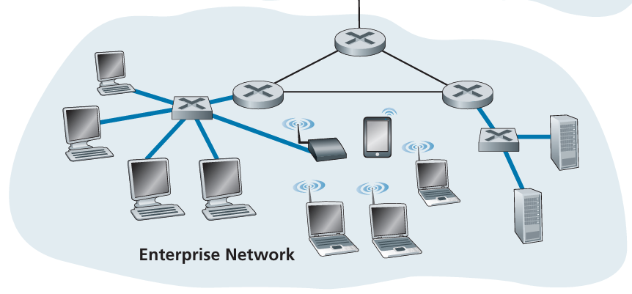
Access ISPs: These are at the bottom tier. They provide internet connectivity directly to end users (like you and me) and businesses. End systems (PCs, smartphones, Web servers, mail servers, and so on) connect into the Internet via an access ISP. The access ISP can provide either wired or wireless connectivity, using an array of access technologies including DSL, cable, FTTH, Wi-Fi, and cellular. Note that the access ISP does not have to be a telco or a cable company; instead it can be, for example, a university (providing Internet access to students, staff, and faculty), or a company (providing access for its employees).
Types of Access Networks
Access networks can be categorized into three main types: residential, institutional, and mobile.
1. Residential Access Networks
These are designed to connect homes to the internet and have evolved significantly over time.
- DSL (Digital Subscriber Line): This technology uses existing twisted-pair copper telephone lines to transmit digital data. It divides the telephone line into three bands: one for telephone calls, and two for upstream and downstream data. This allows you to use the internet and make phone calls simultaneously. A residence typically obtains DSL Internet access from the same local telephone company that provides its wired local phone access. Thus, when DSL is used, a customer’s telephone company is also its ISP.
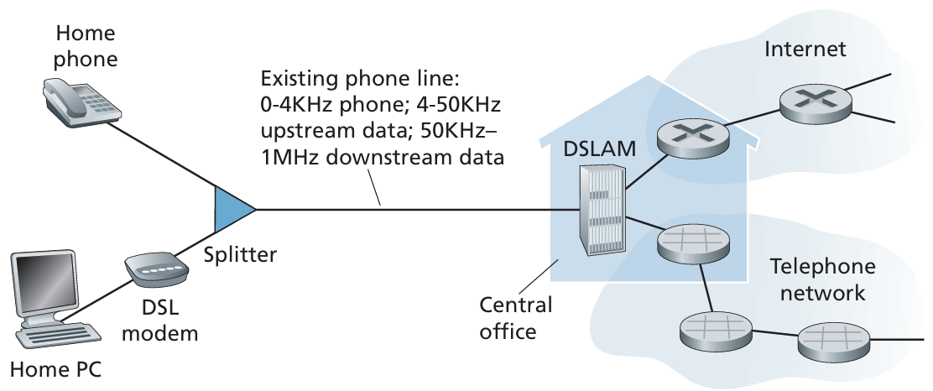
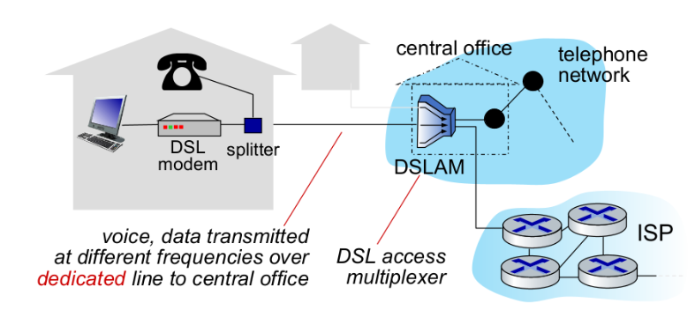
On the customer side, a splitter separates the data and telephone signals arriving to the home and forwards the data signal to the DSL modem and connects to the home PC through an Ethernet port. Its primary purpose is to separate the high-frequency DSL data signal from the low-frequency analog voice signal on the same telephone line. This allows you to use your phone and your DSL internet connection simultaneously on the same copper wire without them interfering with each other.
On the telephone company side, the DSLAM separates the data and phone signals and sends the data into the Internet. Hundreds or even thousands of households connect to a single DSLAM. It involves asymmetric transmission rates which refers to an internet connection where the download speed is significantly faster than the upload speed.
- Cable Internet: This uses the same coaxial cable infrastructure as cable television. A central cable head end station broadcasts data to a neighborhood. From there, the data is distributed via a combination of fiber and coaxial cables to individual homes, it is often referred to as hybrid fiber coax (HFC). A splitter separates the data and television signals arriving to the home and forwards the data signal to the cable modem and connects to the home PC through an Ethernet port. Cable Internet is a shared medium, meaning multiple users in a neighborhood share the same bandwidth, which can lead to slower speeds during peak usage times.
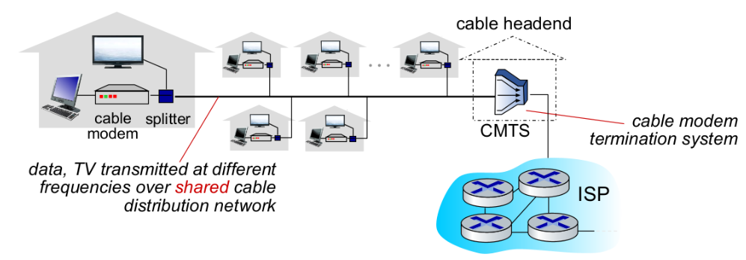
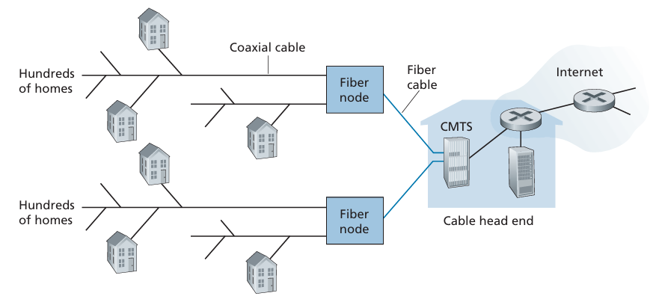
It involves asymmetric transmission rates which refers to an internet connection where the download speed is significantly faster than the upload speed.
Frequency Division Multiplexing (FDM): Cable providers use FDM to send hundreds of TV channels and data over the same coaxial cable. Each channel occupies a different frequency, and they do not interfere with each other. The cable access network has its standards defined which are known as DOCSIS.
The CMTS acts as a router, receiving data from the internet backbone and sending it downstream to individual cable modems. It also receives data sent upstream from cable modems and routes it out to the internet. It acts as the gateway between the internet backbone and the local Hybrid Fiber-Coaxial (HFC) network that connects to your home.

2. Institutional/Enterprise/Home Access Networks
These networks are used in businesses, universities, and other organizations to connect multiple devices within a building or campus.
- Ethernet: The most common wired LAN (Local Area Network) technology. It uses switches and Ethernet cables to connect computers and other devices to a central router. Ethernet is known for its high speed, reliability, and security within a local environment.
- Wireless LANs (WLANs): These use Wi-Fi (802.11 standard) to provide wireless connectivity. Devices connect to an access point (AP), which is then connected to a wired network (router). WLANs offer flexibility and mobility but can have lower speeds and be less secure than wired Ethernet connections as it is a shared wireless access network that connects end system to router.
  - An Access Point (AP) is a networking device that provides wireless connectivity to a wired network (router). It acts as a central hub for wireless devices like smartphones, laptops, and tablets, enabling them to communicate with a local area network (LAN) and the internet without the need for cables.
  - Connection: The access point connects to a router, switch, or hub using a wired Ethernet cable.
  - Broadcast: Once connected, the AP uses its radio transceivers and antennas to transmit wireless signals, creating a Wireless Local Area Network (WLAN)—your Wi-Fi network. 802.11b/g/n (11, 54, 450) Mbps transmission rate
- Home Network: Many homes combine broadband residential access (that is, cable modems or DSL) with these inexpensive wireless LAN (WLAN) technologies to create powerful home networks.
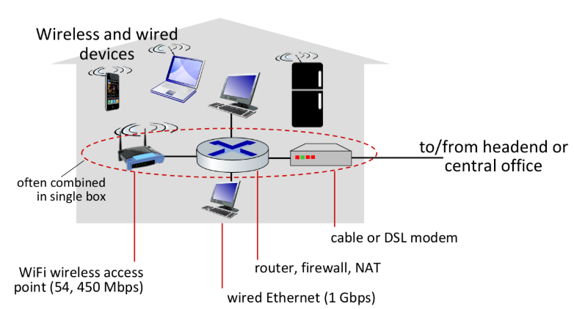
This home network consists of a roaming laptop, multiple Internet-connected home appliances, as well as a wired PC; a base station (the wireless access point), which communicates with the wireless PC and other wireless devices in the home; and a home router that connects the wireless access point, and any other wired home devices, to the Internet.
- Enterprise Network: It is a mix of wired and wireless link technologies, connecting a mix of switches and routers. LANs and WANs, Local Area Networks within a building and Wide Area Networks connecting different locations, often using protocols like Ethernet and Wi-Fi.
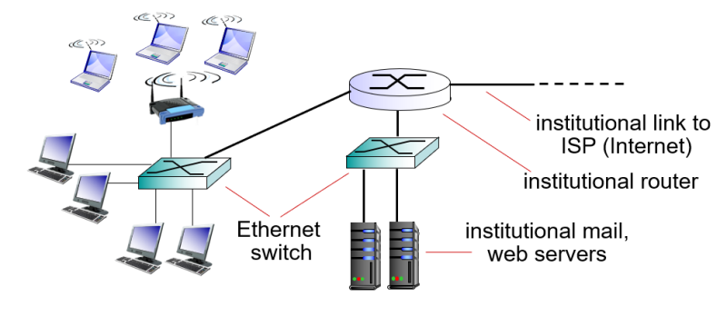

3. Mobile Access Networks
These networks allow devices to connect to the internet while on the move, using cellular technology.
- 3G, 4G/LTE, and 5G: It is known as Wireless Wide Area Network (WWANs). These technologies use cellular base stations (cell towers) to provide wireless internet access over a wide geographic area.
WWAN uses telecommunication cellular network technologies such as 2G, 3G, 4G LTE, and 5G to transfer data.
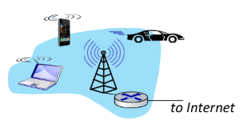
Your mobile device communicates with the nearest base station, which then connects to the cellular provider's core network and, ultimately, the internet. Each successive generation (4G, 5G) offers faster speeds and lower latency.

Physical Media
Physical media are the transmission pathways that carry data signals between network devices. They are broadly categorized into two types: guided and unguided.
- With guided media, the waves are guided along a solid medium, such as a fiber-optic cable, a twisted-pair copper wire, or a coaxial cable.
- With unguided media, the waves propagate in the atmosphere and in outer space, such as in a wireless LAN or a digital satellite channel.
Transmitter-Receiver Pair: Consider a bit, when traveling from source to destination, passes through a series of transmitter-receiver pairs. The router which sends-out/transmits the bit is the ‘transmitter’ and the router that receives that bit is the ‘receiver’, this is known as the transmitter-receiver pair.
For each transmitter-receiver pair, the bit is sent by propagating electromagnetic waves or optical pulses across a physical medium. The physical medium can take many shapes and forms and does not have to be of the same type for each transmitter-receiver pair along the path/route.

Guided Media
1. Twisted-Pair Cable
It consists of two insulated copper wires twisted together to reduce electromagnetic interference (EMI). The twisting cancels out noise from nearby wires and external sources.
Typically, a number of pairs are bundled together in a cable by wrapping the pairs in a protective shield which is known as Shielded Twisted Pair (STP). A wire pair constitutes a single communication link. Unshielded twisted pair (UTP) is commonly used for computer networks within a building, that is, for LANs. Data rates for LANs using twisted pair today range from 10 Mbps to 10 Gbps. The data rates that can be achieved depend on the thickness of the wire and the distance between transmitter and receiver.
Modern twisted-pair technology, such as category 6a cable, can achieve data rates of 10 Gbps for distances up to a hundred meters. In the end, twisted pair has emerged as the dominant solution for high-speed LAN networking.
DSL (Digital Subscriber Line) is a technology that provides high-speed internet access over the same twisted-pair copper wires used for traditional telephone service. It uses different frequency bands for data and voice, which allows for simultaneous phone calls and internet use. When users live close to the ISP’s central office, users can access the Internet at tens of Mbps.
2. Coaxial Cable
It consists of two concentric copper conductors, but the two conductors are concentric rather than parallel like in twisted pair. It can carry signals over long distances with high bandwidth. It is bidirectional. This means it can transmit data in both directions simultaneously. To achieve this, it uses different frequency bands for the upstream (upload) and downstream (download) data.
Coaxial cables are commonly used for cable television and to provide residential internet access via cable modems. It has many channels, each with different frequency. It has total of 3 bands: 1 for television signal, and two for upstream and downstream.
Coaxial cable is a type of guided physical medium used for data transmission.
- Common Use: It is widely used in cable television systems and for providing high-speed internet access to homes via cable modems.
- Shared Medium: A key characteristic is that it acts as a shared medium, meaning multiple users can connect to the same cable and share the available bandwidth. This can lead to slower speeds during peak usage times.
3. Fiber Optic Cable
Fiber optic cable transmits data as pulses of light and can carry huge amounts of data over vast distances. It consists of a thin glass or plastic core. This is the fastest and most reliable guided medium. Each pulse represents a bit. As these light pulses travel over long distances, they start to lose their speed. To combat this signal degradation and boost the signal, repeaters are strategically placed at intervals along the cable.
- Advantages: Fiber optic cables are immune to EMI, can transmit data over very long distances with minimal signal degradation, and offer extremely high bandwidth.
- Disadvantages: They are more expensive to install and more fragile than copper cables.

Unguided Media
1. Radio Waves
Radio waves are used for a wide range of wireless communication, including Wi-Fi, Bluetooth, and cellular networks. They are omnidirectional, meaning they can travel in all directions from the source, and can penetrate walls and buildings, making them highly versatile.
Wireless radio signals are a type of unguided media that transmit data through the air using different frequencies, or bands, within the electromagnetic spectrum. Unlike wired connections, there is no physical wire to guide the signal.
Radio signals are often broadcast, meaning they are sent out in all directions. The communication is often half-duplex, which means a device can either send or receive data at a given time, but not both simultaneously.
Environmental Effects
The quality and reliability of a wireless connection are affected by the surrounding environment:
- Reflection: Signals can bounce off objects like walls, creating multiple copies of the same signal that can arrive at the receiver at different times and cause distortion.
- Obstruction: Objects such as walls, buildings, or even trees can block or weaken the signal.
- Interference/Noise: Other wireless devices or electronic equipment operating on the same frequency can interfere with the signal, reducing its quality and speed.
Types of Radio Links
Different types of wireless radio links are used for various applications, each with its own characteristics:
- Wireless LAN (Wi-Fi): Provides internet access over short distances, typically within a building. It offers speeds ranging from 10 to hundreds of Mbps over a range of tens of meters.
- Wide-Area Cellular: This is the technology used for mobile phones, such as 4G and 5G. It covers large areas, with speeds around 10s of Mbps for 4G and much faster for 5G, over a range of several kilometers.
- Bluetooth: Used as a cable replacement for connecting devices over very short distances, like wireless headphones. It has limited speeds and a short range.
- Terrestrial Microwave: Used for point-to-point communication between two fixed locations, like connecting two buildings. It requires a clear line of sight and can offer speeds around 45 Mbps.
- Satellite: Provides internet access from space. Satellites can deliver high speeds (up to 100 Mbps or more with technologies like Starlink) but often have a high end-to-end delay (around 270 milliseconds for geostationary satellites) due to the long distance the signal must travel to and from space.

The Network Core
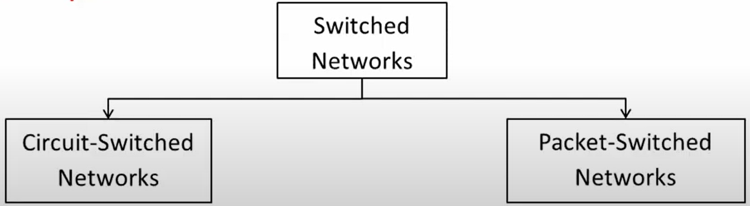

Circuit Switching (First Half)
Circuit switching is a communication method where a dedicated communication path, or circuit, is established between two devices before data transmission begins. The circuit remains dedicated to the communication for the duration of the session, and no other devices can use it while the session is active. Circuit switching is commonly used in voice communication (telephone) requiring real time services without delay.
For half duplex (one way) communication, one channel is allocated, and for full duplex (two way) communication, two channels are allocated.
This type of connection receives complete bandwidth of the network until the data is transferred completely. However, circuit switching can be inefficient and costly due to its requirement for dedicated resources, making it less suitable for high-traffic or large-scale networks.
In circuit switching network resources (bandwidth) are divided into pieces and the bit delay is constant during a connection. The dedicated path/circuit established between the sender and receiver provides a guaranteed data rate. Data can be transmitted without any delays once the circuit is established.
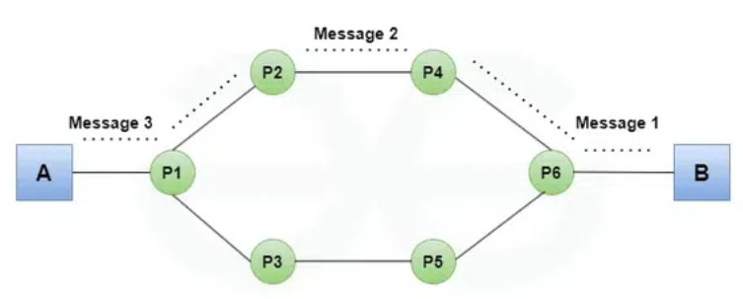
Three phases of circuit switching are:
- Circuit Establishment
- Data Transfer
- Circuit Disconnect
Advantages of Circuit Switching
- Guaranteed bandwidth: Circuit switching provides a dedicated path for communication, ensuring that bandwidth is guaranteed for the duration of the call.
- Low latency: Circuit switching provides low latency because the path is predetermined, and there is no need to establish a connection for each packet.
- Predictable performance: Circuit switching provides predictable performance because the bandwidth is reserved, and there is no competition for resources.
- Suitable for real-time communication: Circuit switching is suitable for real-time communication, such as voice and video, because it provides low latency and predictable performance.
Disadvantages of Circuit Switching
- Inefficient use of bandwidth: Circuit switching is inefficient because the bandwidth is reserved for the entire duration of the call even when no data is being transmitted.
- Limited scalability: Circuit switching is limited in its scalability because the number of circuits that can be established is finite, which can limit the number of simultaneous calls that can be made.
- High cost: Circuit switching is expensive because it requires dedicated resources, such as hardware and bandwidth for the duration of the call.

Packet Switching
This is the core method for moving data on the internet. Data is broken down into small, manageable chunks called packets. Each packet travels independently through the network and is reassembled at the destination. This is more efficient than a dedicated connection (circuit switching), as it allows multiple users to share the same network links. It does not require to establish a connection first. The connections/channels are available to use for users. It is mainly used for data and voice applications requiring non-real time scenarios.
Each packet contains the source and destination addresses, as well as other information needed for routing. The packets may take different paths/links to reach their destination, and they may be transmitted out of order or delayed due to network congestion.
Advantages of Packet Switching
- Efficient use of bandwidth: Packet switching is efficient because bandwidth is shared among multiple users and resources are allocated only when data needs to be transmitted.
- Flexible: Packet switching is flexible and can handle a wide range of data rates and packet sizes.
- Scalable: Packet switching is highly scalable and can handle large amounts of traffic on a network.
- Lower cost: Packet switching is less expensive than circuit switching because resources are shared among multiple users.
Disadvantages of Packet Switching
- Higher latency: Packet switching has higher latency than circuit switching because packets must be routed through multiple nodes which can cause delay.
- Limited Quality of Service (QoS): Packet switching provides limited QoS guarantees. It means that different types of traffic may be treated equally.
- Packet loss: Packet switching can result in packet loss due to congestion on the network or errors in transmission.
- Unsuitable for real-time communication: Packet switching is not suitable for real-time communication, such as voice and video, because of the potential for latency and packet loss.

Packet-Switched Networks
Packet-switched networks (which transport packets) are in many ways similar to transportation networks of highways, roads, and intersections (which transport vehicles). Consider, for example, a factory that needs to move a large amount of cargo to some destination warehouse located thousands of kilometers away. At the factory, the cargo is segmented and loaded into a fleet of trucks. Each of the trucks then independently travels through the network of highways, roads, and intersections to the destination warehouse. At the destination warehouse, the cargo is unloaded and grouped with the rest of the cargo arriving from the same shipment. Thus, in many ways, packets are analogous to trucks, communication links are analogous to highways and roads, packet switches are analogous to intersections, and end systems are analogous to buildings. Just as a truck takes a path through the transportation network, a packet takes a path through a computer network.

Packet Switching Vs Dedicated Connection
Packet switching breaks data into packets that take independent, variable paths across a shared network, providing efficiency and cost-effectiveness, while dedicated connections (circuit switching) establish a fixed, reserved path for the entire session, ensuring predictable performance and quality but being less efficient and more expensive. Packet switching is used for the internet and IP networks, whereas dedicated connections were historically used for phone calls and can be seen in some optical networks.
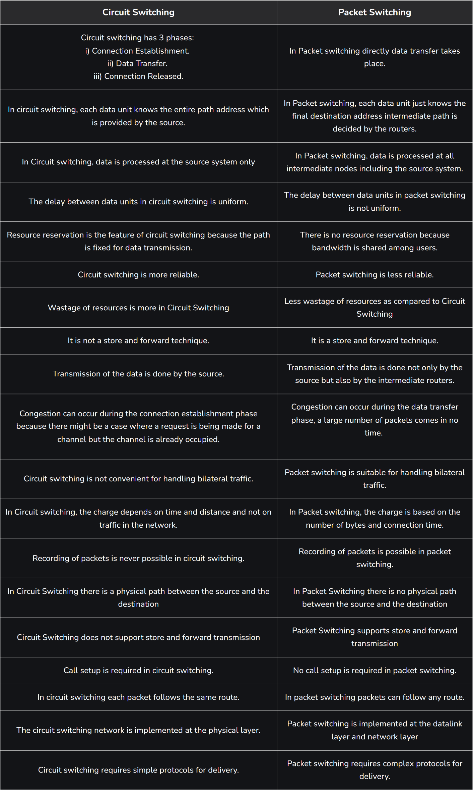


Packet Switches
To send a message from a source end system to a destination end system, the source breaks long messages into smaller chunks of data known as packets. Between source and destination, each packet travels through communication links and packet switches (for which there are two predominant types, routers and link-layer switches). Packets are transmitted over each communication link at a rate equal to the full transmission rate of the link. So, if a source end system or a packet switch is sending a packet of length L bits over a link with transmission rate R bits/sec, then the time to transmit the packet is L / R seconds.
The host transmits packet into access network at transmission rate R. Link transmission rate refers to link capacity, aka link bandwidth.
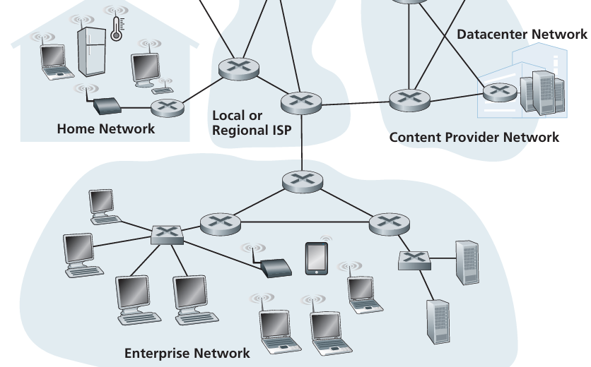

Routers & Link-Layer Switches
Packet switch routers operate at the Network Layer (Layer 3), using IP addresses to connect and forward data between different networks, while link-layer switches function at the Data Link Layer (Layer 2), using MAC addresses to forward data frames within a single network (LAN). Both devices employ packet switching to move data but at different levels of the network hierarchy, with routers managing inter-network traffic and switches handling intra-network traffic.
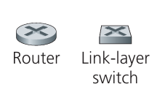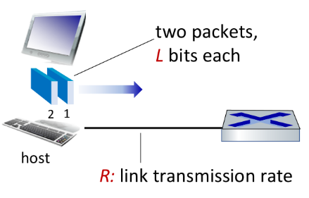
Packet-Switching Routers
- Function: Routers connect different networks together, acting as traffic directors for inter-network communication.
- Layer: They operate at the Network Layer (Layer 3) of the OSI model.
- Addressing: Routers use IP addresses to make decisions about where to forward data packets.
- Data Unit: Data is handled in the form of packets.
- Purpose: To route data from its source to its destination, traversing multiple networks.
- Example: When you send data from your computer to a website, a router determines the best path across the internet for your packets.
Link-Layer Switches
- Function: Switches create connections and forward data within a single local area network (LAN).
- Layer: They operate at the Data Link Layer (Layer 2) of the OSI model.
- Addressing: Switches use MAC addresses (hardware addresses) to identify and send data to the correct device on the local network.
- Data Unit: Data is handled in the form of frames.
- Purpose: To facilitate communication between devices on the same network, unlike hubs that would broadcast data to all devices.
- Example: A switch in your home or office connects your computers, printers, and other devices, directing traffic only to the intended recipient.
The sequence of communication links and packet switches traversed by a packet from the sending end system to the receiving end system is known as a route or path through the network.

Store-and-Forward Transmission in Packet Switches
Most packet switches use store-and-forward transmission at the inputs to the links. Store-and-forward transmission means that the packet switch must receive the entire packet before it can begin to transmit the first bit of the packet onto the outbound link. Each packet switch has multiple links attached to it. For each attached link, the packet switch has an output buffer (also called an output queue), which stores packets that the router is about to send into that link.
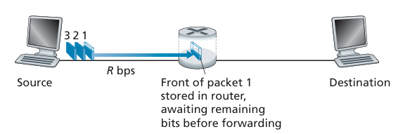
Now let’s calculate the amount of time that elapses from when the source begins to send the first packet until the destination has received all three packets. As before, at time L/R, the router begins to forward the first packet. But also, at time L/R the source will begin to send the second packet, since it has just finished sending the entire first packet. Thus, at time 2L/R, the destination has received the first packet, and the router has received the second packet. Similarly, at time 3L/R, the destination has received the first two packets, and the router has received the third packet. Finally, at time 4L/R the destination has received all three packets!
Let’s now consider the general case of sending one packet from source to destination over a path consisting of N links each of rate R (thus, there are N-1 routers between source and destination). Applying the same logic as above, we see that the end-to-end delay is:
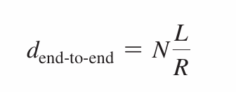
You may now want to try to determine what the delay would be for P packets sent over a series of N links.

Example:
1. Identify the Given Values
First, we need to identify the variables provided in the problem statement.
- Packet size (L) = 10 Kbits
- Transmission rate (R) = 100 Mbps
2. Standardize the Units
To perform the calculation, the units of the packet size and transmission rate must be consistent. We will convert both values to bits and bits per second, respectively.
- Packet size (L):
  - 1 Kbit=10³ bits
  - L=10 Kbits=10×10³=10,000 bits
- Transmission rate (R):
  - 1 Mbps=10⁶ bits/sec
  - R=100 Mbps=100×10⁶=10⁸ bits/sec
3. Calculate the Transmission Delay
The formula for transmission delay is the packet size divided by the transmission rate. Transmission Delay=L/R​
Now, we can plug in the standardized values: Transmission Delay= 10,000 bits / 10⁸ bits/sec​
Transmission Delay=0.0001 seconds
4. Convert to Milliseconds
To compare our result with the value given in the problem, we convert the transmission delay from seconds to milliseconds.
- 1 second=1000 milliseconds = 10³
- Transmission Delay=0.0001 seconds×1000 msec/sec=0.1 msec

Queuing Delays and Packet Loss
A packet switch has an output buffer (or queue) for each outgoing link. When a packet arrives and wants to be sent on a link that is already busy, it must wait in this buffer. This waiting time is called queuing delay. Queueing occurs when work (packets) arrives faster than it can be serviced (transmission rate).
Queuing Delays
- Variable: This delay is not fixed; it changes depending on the amount of network congestion.
- Cause: It occurs when the rate at which packets arrive at the router exceeds the rate at which the router can send them out on a particular link.
Packet Loss
- Cause: The output buffer has a limited, finite amount of space. If an incoming packet finds the buffer completely full, it can't be stored.
- Result: The router has to drop, or discard either the arriving packet or one of the already-queued packets will be dropped. This is known as packet loss.
In summary, queuing delay is the time a packet waits in a buffer due to network congestion, while packet loss is what happens when a packet is dropped because the buffer is full. The same principle of queuing and loss applies to link-layer switches, When the buffer is full, any new frames arriving for that link will be dropped, resulting in packet (frame) loss.
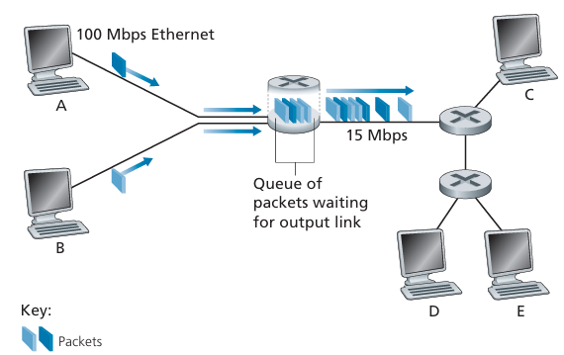
Scenario: Suppose Hosts A and B are sending packets to Host E. Hosts A and B first send their packets along 100 Mbps Ethernet links to the first router. The router then directs these packets to the 15 Mbps transmission rate link. If, during a short interval of time, the arrival rate of packets to the router (when converted to bits per second) exceeds 15 Mbps transmission rate, congestion will occur at the router as packets queue in the link’s output buffer before being transmitted onto the link. For example, if Host A and B each send a burst of five packets back-to-back at the same time, then most of these packets will spend some time waiting in the queue.

Router Hop
In networking, a hop is the movement of a data packet from one network device to the next, typically a router, along the path to its destination. The hop count is the total number of these intermediate devices a packet passes through to reach its destination. Each router the packet passes through increases the hop count by 1.
A hop is not counted on a link-layer switch. A link-layer switch, on the other hand, operates at the link layer and simply forwards frames within the same local network. It doesn't count as a hop because it isn't moving the packet to a new network.
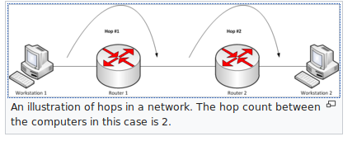
If the hop count exceeds the maximum hop limit the packet is discarded and the network is considered unreachable.
Routing table updates occur periodically or when topology change. Routers send their entire routing table to all adjacent neighbours. Routing protocols often use hop count as their primary metric to find the shortest or best path. Routing table contains info about routing metrics:
- Hop count
- Bandwidth
- Cost
- Load
- Reliability
- Delay
Time to Live (TTL): In the context of IP packets, the TTL field acts as a countdown timer. Each router decrements the TTL by one. If a packet's TTL reaches zero, the router discards it, preventing it from circulating indefinitely in the network and creating routing loops.
Loop Prevention: By tracking hops and setting a maximum limit (e.g., 15 in some systems), networks can prevent packets from endlessly looping between routers.
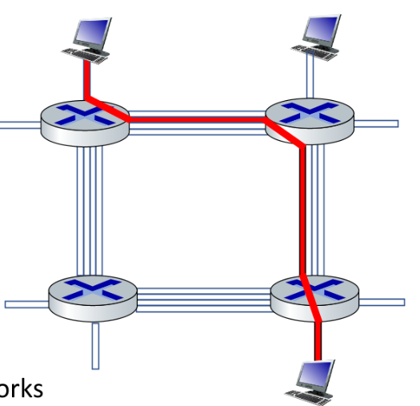
Hops: The route shown in red line has three hops. A hop is the travel of a data packet from one router to the next. In the image, the packet starts at the top-left computer, travels through three routers, and arrives at the bottom-right computer, resulting in three hops.
Circuits: Each link has four circuits/links. The blue lines connecting the routers are shown as four distinct parallel lines. Each physical link between two routers contains four separate communication channels or circuits, allowing for multiple data streams to be transmitted simultaneously.

Two Key Network Core Functions
The two key functions of the network core are forwarding and routing. These functions are crucial for moving data packets through the vast network of routers that make up the internet.
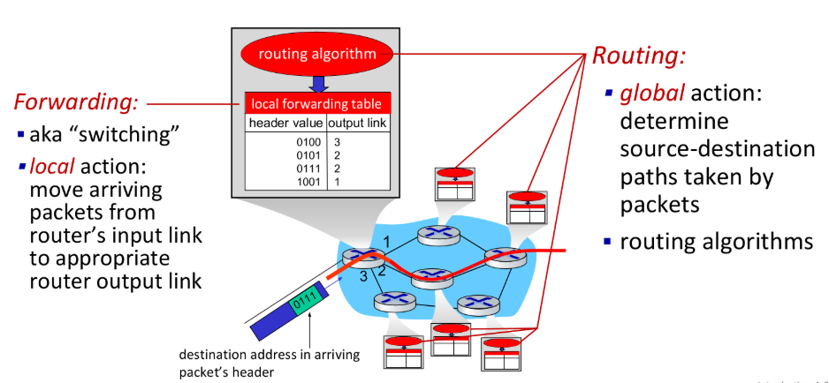
1. Forwarding (The Local Action)
Forwarding is the process of a router moving a packet from an input port to the correct output port. Think of it as a local action performed at each individual router. When a packet arrives, the router looks at its destination address and uses a forwarding table (also known as a flow table or lookup table) to determine which outgoing link to send the packet on. This process is very fast and is often implemented in hardware.
How it works:
- A packet arrives at a router.
- The router checks the packet's destination IP address.
- It then searches its forwarding table for the best match for that address.
- Once a match is found, the router sends the packet out on the corresponding link.
This process is repeated at every router the packet encounters until it reaches its final destination.

2. Routing (The Global Process)
Routing is the process of determining the entire path that data packets will take from the source to the destination. It involves routers using routing algorithms to collectively build the forwarding tables. These algorithms consider factors like the number of hops, network congestion, and link costs to find the most efficient path. Routing is a network-wide, "global" process that establishes the routes/paths, while forwarding is the per-router action that uses those established routes.
In short, routing is about planning the trip, and forwarding is about getting the packet on the correct street at each intersection.
How are Forwarding Tables created?
Forwarding tables are not configured manually. Instead, the internet uses routing protocols to automatically create and update them. A routing protocol can calculate the most efficient path (e.g., the shortest path) for data to travel from one router to another and then uses that information to populate the forwarding tables in all routers on the network.

Circuit Switching (Second Half)
In circuit-switched networks, the resources needed along a path (buffers, link transmission rate) to provide for communication between the end systems are reserved for the duration of the communication session between the end systems. If the user is idle, the resources are being wasted.
In packet-switched networks, these resources are not reserved; a session’s messages use the resources on demand and, as a consequence, may have to wait (that is, queue) for access to a communication link.
Traditional telephone networks are examples of circuit-switched networks. Consider what happens when one person wants to send information (voice) to another over a telephone network. Before the sender can send the information, the network must establish a connection between the sender and the receiver. This is a bona fide connection for which the switches on the path between the sender and receiver maintain connection state for that connection. In the jargon of telephony, this connection is called a circuit.
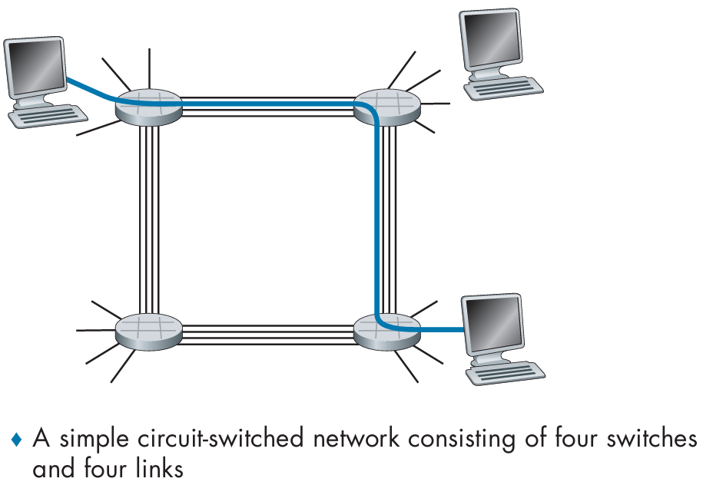
- Switches: The four circular devices are the circuit switches that connect the links.
- Links: The lines connecting the switches are the communication links. Each link is shown with four black lines, indicating it has four separate circuits or communication channels.
The Dedicated Circuit
The blue line running from the top-left host to the bottom-right host represents a dedicated, end-to-end circuit.
- Establishment: Before any data is sent, the network sets up this specific path.
- Resource Reservation: A single circuit on each link along the path is reserved for this connection. For instance, the top link uses one of its four circuits, and the right-side link uses one of its four circuits.
- Guaranteed Bandwidth: Once the circuit is established, this connection gets a guaranteed fraction of the link's total bandwidth (in this case, one-fourth of the bandwidth on each link) for the entire duration of the communication. This means the two hosts can communicate without any queuing delays or interference from other traffic.
- No Sharing: The reserved circuit cannot be used by any other host until the connection is terminated. This is a key difference from a packet-switched network, where resources are shared.
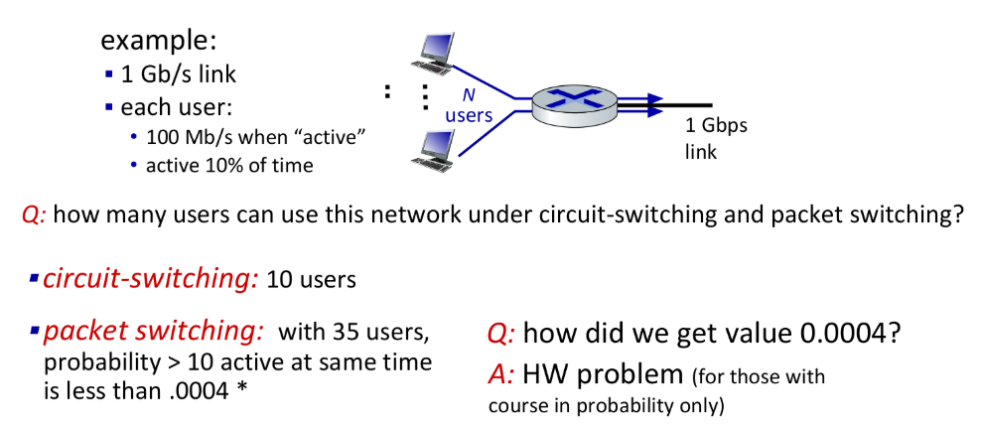
Circuit Switching 📞
Under a circuit-switching model, a dedicated, guaranteed portion of the link's bandwidth is reserved for each user. The network must allocate bandwidth for a user for the entire duration of their connection, even when they're not actively transmitting data.
- Total Link Bandwidth: 1 Gbps = 1,000 Mbps
- Bandwidth per User: 100 Mbps
To find the number of users the network can support, we divide the total bandwidth by the bandwidth required per user:
1000 Mbps÷100 Mbps/user=10 users
So, the link can support a maximum of 10 users simultaneously with a circuit-switched approach. No more than 10 connections can be active at the same time, because the network guarantees each user 100 Mbps, regardless of their activity.
Packet Switching 📦
Under a packet-switching model, the network does not reserve any bandwidth. Users share the link's total bandwidth on demand. This approach takes advantage of the fact that users are only active for a small fraction of the time.
- Total Link Bandwidth: 1,000 Mbps
- User Activity: Active 10% of the time (transmitting at 100 Mbps) and idle 90% of the time.
The network can handle more users because it assumes that not all users will be active at the same time. The example states that with 35 users, the probability of more than 10 users being active simultaneously is very low (less than 0.0004). This is because the system is designed based on statistical multiplexing, where the network assumes that the total bandwidth required by all users at any given moment will not exceed the link's capacity.
- Scenario 1 (Worst Case): If more than 10 users become active at the same time, the combined data rate required will exceed the link's 1,000 Mbps capacity. This will lead to queuing delays and packet loss.
- Scenario 2 (Probable Case): The vast majority of the time, fewer than 10 users will be active, and the network will operate efficiently, with each user getting their full 100 Mbps when they need it.

Multiplexing in Circuit-Switched Networks
A circuit in a link is implemented with either frequency-division multiplexing (FDM) or time-division multiplexing (TDM).
In FDM, the total frequency spectrum of a physical link is divided into multiple, smaller, and non-overlapping frequency bands. Each communication session is assigned its own dedicated frequency band for the entire duration of the connection. This allows multiple data signals to be transmitted simultaneously on the same link without interfering with each other.
In telephone networks, this frequency band typically has a width of 4kHz (that is, 4,000 hertz or 4,000 cycles per second). The width of the band is called the bandwidth.
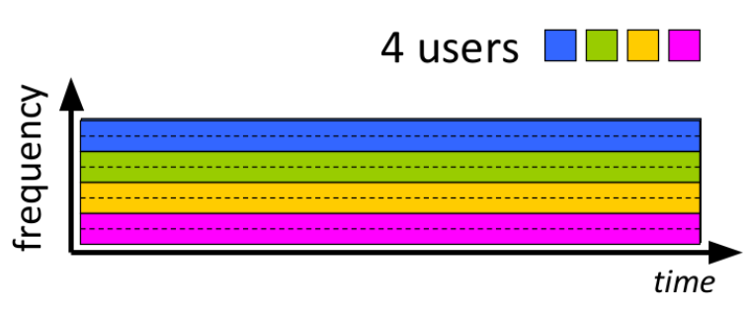
Each telephone call is allocated its own dedicated band. It can transmit voice signals at maximum transmission rate of that narrow band.

In TDM, time is divided into fixed-duration frames, and each frame is split into a fixed number of time slots. Each connection is allocated a specific, dedicated time slot in every frame. It's like a conveyor belt with assigned slots; your data only gets to use your specific slot as it comes around in each cycle.
A physical link's total bandwidth is divided among multiple connections by allocating each one a dedicated slice of time.
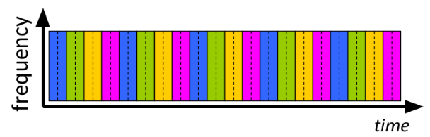
Each telephone call is allocated a time slot in every frame. It can transmit voice signals at maximum transmission rate of the whole frequency band of the link during its time slot(s). The signal has the whole link to itself for that split second. If a physical is of 1 Mbps, convert that into a split second, the link transmits 5 bits per split second. Then, the connection will use the whole capacity of the link for that allocated tiny time slot which is 5 bits.
Let’s say a physical link’s capacity is 800 bps. There are 10 channels in a frame.
- Total Link Bandwidth: 800 bps
- Total Time Slots: 10 slots per frame
- Frame Rate: 800 bps / (10 slots * 8 bits) => 800 / 80 => 10 frames per second
- Bits per Slot: 8 bits

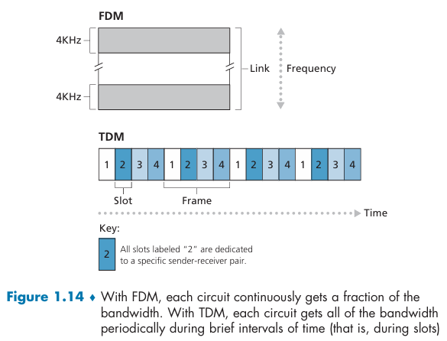
In TDM networking, channels are created by dividing the available time on a single high-bandwidth physical link into discrete time slots, each dedicated to a specific low-bandwidth data stream or signal. These signals are then interleaved, or “time-sliced,” into fixed-length segments and sent in a round-robin fashion over the shared channel. At the destination, the data is demultiplexed back into its original, separate channels. The multiplexer takes a small segment of data from each input channel, one by one, and interleaves them into a single, combined data stream.
Frame Formation: These interleaved segments from all the channels form a "frame". For example, in a T1 line carrying 24 channels, a 193-bit frame consists of 8 bits from each of the 24 channels, plus a synchronization bit. This combined frame, containing data from all channels, is transmitted over the single physical link.

Wastefulness
A major criticism of circuit switching is that it can be wasteful. The dedicated resources (frequency bands or time slots) remain reserved even during periods when no data is being sent. This idle time cannot be used by other connections, which makes the network inefficient. Packet switching, by contrast, is more efficient as resources are shared on demand.
In frequency division multiplexing all the signals operate at the same time with different frequencies, but in time-division multiplexing, all the signals operate with the same frequency at different times.

Numerical Examples:
In TDM, a physical link's total bandwidth is divided among multiple connections by allocating each one a dedicated slice of time.
TDM Example: A Telephone System 📞
Consider a circuit-switched telephone network with a link connecting two switches.
- Total Link Bandwidth: 1.536 Mbps
- Total Time Slots: 24 slots per frame
- Frame Rate: 8,000 frames per second
- Bits per Slot: 8 bits
1. Calculating a Single Circuit's Speed
To find the transmission rate for a single connection, we first calculate the total number of bits transmitted in one second.
Total bits/sec = Total slots per frame × Bits per slot × Frame rate Total bits/sec = 24 slots × 8 bits/slot × 8,000 frames/sec = 1,536,000 bits/sec or 1.536 Mbps
Each of the 24 connections gets one dedicated slot per frame. So, each connection's data rate is:
Circuit Rate = (Bits per slot × Frame rate) = (8 bits × 8,000 frames/sec) = 64,000 bits/sec or 64 kbps
Alternatively, you can divide the total link bandwidth by the number of slots:
Circuit Rate = (Total Link Bandwidth) / (Total Slots) = (1.536 Mbps) / 24 = 64 kbps
This means each of the 24 telephone calls on this link is guaranteed a constant 64 kbps data rate for the entire call, regardless of how many others are talking.
2. Practical Scenario: Sending a File
Let's see how long it would take to send a 640,000-bit file from Host A to Host B over this network.
- File Size: 640,000 bits
- Circuit Rate: 64 kbps (or 64,000 bits/sec)
Transmission Time = File Size / Circuit Rate Transmission Time = 640,000 bits / 64,000 bits/sec = 10 seconds
It's important to remember that in a circuit-switched network, there is an additional circuit establishment time before transmission can begin. If this setup takes, say, 500 milliseconds (0.5 seconds), the total time would be:
Total Time = Establishment Time + Transmission Time Total Time = 0.5 sec + 10 sec = 10.5 seconds
The key takeaway is that once the circuit is established, the transmission time is constant and predictable, unaffected by other traffic.

Another example:
let’s say a physical link can transmit 800 bits per second. And we have 10 slots with 8 bits capacity. That means we have 10 channels in a single frame. So, each user gets a single slot, then if a single user is only allowed to transmit data for a single slot in a second, how can possibly that user use the whole 800 bps data transfer rate? He can’t, because he has only a tiny slot inside a second.
The Math of TDM 🕰️
Your example is perfect for clarifying this.
- Total Link Bandwidth: 800 bits per second (bps)
- Slots per Frame: 10 slots
- Slot Capacity: 8 bits per slot
This means that for the link to transmit 800 bits in one second, a "frame" (which contains all 10 slots) must be transmitted 10 times per second.
- Frame Rate: 800 bps / 80 bits per frame = 10 frames per second
Each user gets one slot per frame. Since there are 10 frames per second, a single user gets to transmit their 8-bit data segment 10 times per second.
How a User Gets Full Bandwidth
The key is the word "instantaneously" or "at that moment."
- When it's User A's turn (their time slot), the system "flips a switch" and dedicates the entire 800 bps capacity of the physical link to them.
- The link sends User A's 8 bits at the full 800 bps speed. The time it takes to send those 8 bits is incredibly short: 8 bits / 800 bps = 0.01 seconds.
- After that 0.01-second period, the link then sends the next user's 8 bits, also at the full 800 bps rate.

Numerical
Question 1: A file of size 500MB is to be sent through a series of links:
- Link A: 100mbps, length of physical link 4000km
- Link B: 50mbps, length of physical link 5000km
- Link C: 200mbps, length of physical link 2000km
Propagation delay = 2.5 x 10^8 meter/second
- Calculate transmission delay and propagation delay for each link.
- Calculate the total transmission delay and the total propagation delay.
- Identify the bottleneck link, and its reason.
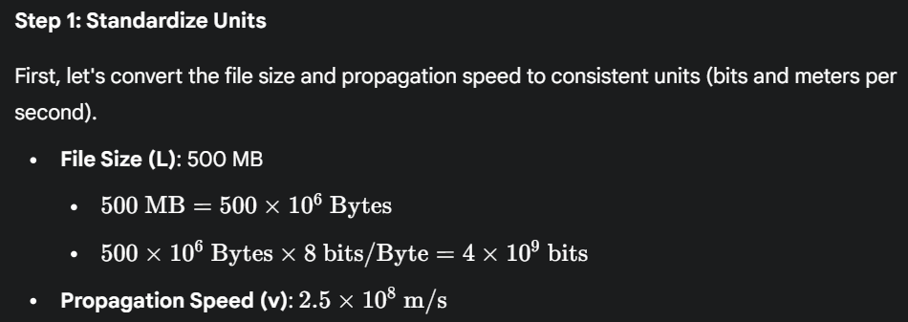
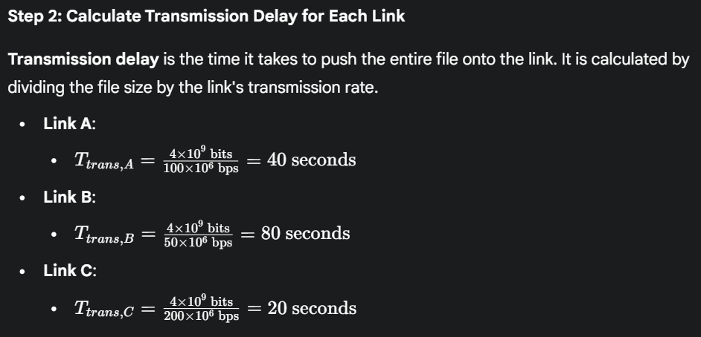
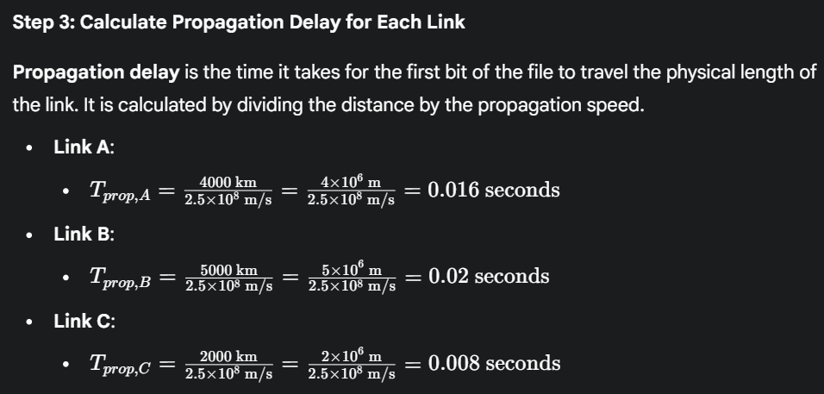
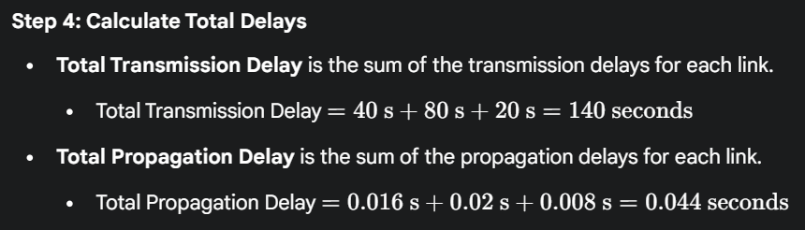
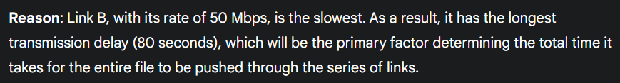

A Network of Networks
End systems (PCs, smartphones, Web servers, mail servers, and so on) connect into the Internet via an access ISP. The access ISP can provide either wired or wireless connectivity, using an array of access technologies including DSL, cable, FTTH, Wi-Fi, and cellular. Note that the access ISP does not have to be a telco or a cable company; instead, it can be, for example, a university (providing Internet access to students, staff, and faculty), or a company (providing access for its employees).
The access ISPs themselves must be interconnected. This is done by creating a network of networks.
The Hierarchical Structure
The Internet is organized into different tiers, primarily driven by economics.
- Access ISPs: These are at the bottom tier. They provide internet connectivity directly to end users (like you and me) and businesses. Examples include local cable or phone companies.
- Regional ISPs: These ISPs connect many smaller access ISPs within a specific geographical area. They act as an intermediary, routing traffic for their customers.
- Tier-1 ISPs: These are at the top of the hierarchy. They are large, global ISPs that connect to each other but do not pay anyone for transit. Examples include AT&T and Verizon.
This structure forms a customer-provider relationship: Access ISPs pay Regional ISPs, and Regional ISPs pay Tier-1 ISPs to access the rest of the Internet. Tier-1 ISPs are the backbone and do not pay others.
Key Components That Interconnect the Tiers
To make this hierarchy work and to improve efficiency, several key components are used:
- Points of Presence (PoPs): These are physical locations with routers where an ISP allows its customers to connect to its network.
- Multi-homing: An ISP (except for Tier-1 ISPs) can connect to two or more provider ISPs. This provides redundancy and improves reliability.
- Peering: Two ISPs at the same level (e.g., two regional ISPs or two Tier-1 ISPs) can directly connect their networks to exchange traffic without having to pay a higher-tier ISP. This is often "settlement-free."
- Internet Exchange Points (IXPs): These are physical locations where multiple ISPs can come together to peer and exchange traffic.

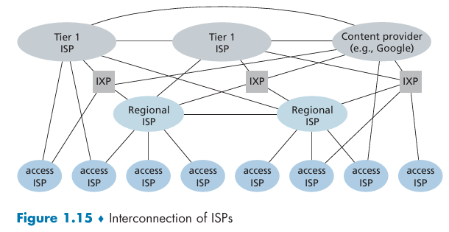
The Role of Content Providers
Instead of relying solely on a network of ISPs, a major content provider like Google (YouTube, Search) or Netflix operates its own global, private network. This network connects their massive data centers, which house servers and data, directly to end-users. This allows them to:
- Bypass upper tiers by directly peering with lower-tier ISPs (access and regional ISPs) and IXPs.
- Connect to Tier-1 ISPs: Despite their efforts to peer directly, some traffic still needs to travel through Tier-1 networks to reach certain areas. For this traffic, the content provider becomes a customer and pays the Tier-1 ISP.
- Reduce costs by avoiding expensive payments to Tier-1 ISPs.
- Performance and control over the delivery of their services to end users.

Delay, Loss, and Throughput in Packet-Switched Networks
A packet starts in a host (the source), passes through a series of routers, and ends its journey in another host (the destination). As a packet travels from one node (host or router) to the subsequent node (host or router) along this path, the packet suffers from several types of delays at each node along the path. The most important of these delays are the nodal processing delay, queuing delay, transmission delay, and propagation delay; together, these delays accumulate to give a total nodal delay.
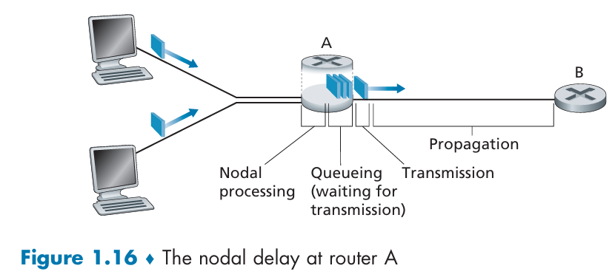
When a packet arrives at router A from the upstream node, router A examines the packet’s header for destination IP address to determine the appropriate outbound link for the packet and then directs the packet to this link.
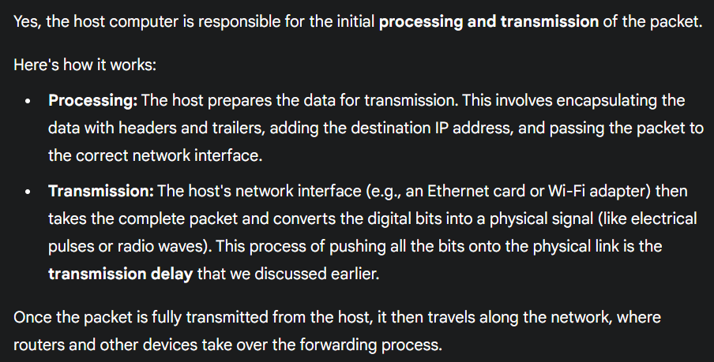
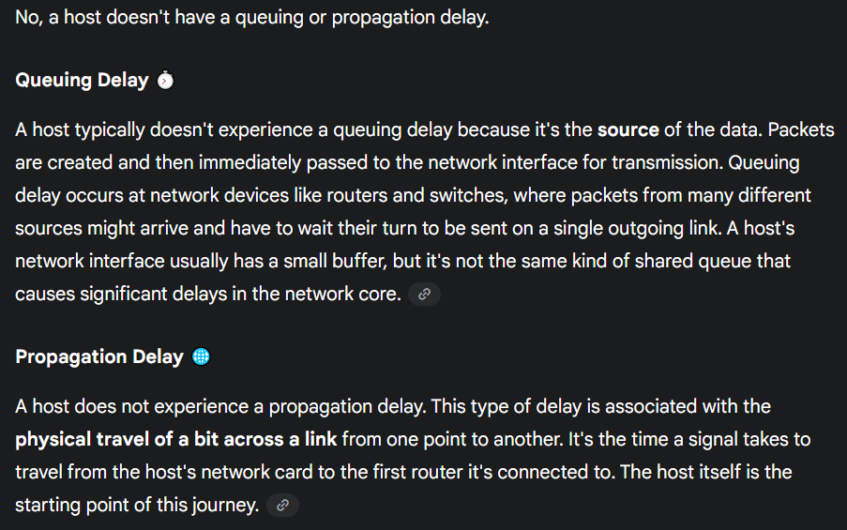

Types of Delays
At each network node (like a router), a packet experiences four types of delays:
- Processing Delay: The time required to examine the packet’s header and determine where to direct the packet is part of the processing delay. The processing delay can also include other factors, such as the time needed to check for bit-level errors in the packet that occurred in transmitting the packet’s bits from the upstream node to router A.
- Queuing Delay: The time a packet waits in a queue (or buffer) to be transmitted onto the link. This delay varies depending on network traffic and can be anywhere from microseconds to milliseconds.
- Transmission Delay: The time it takes to push all of the packet's bits onto the link. This is calculated as the packet's size (L) divided by the link's transmission rate (R). It's the time spent at the router itself to transmit the packet from the router.
- Propagation Delay: The time it takes for a single bit to travel from the beginning of a link to its end. This is determined by the distance (d) of the link divided by the signal's propagation speed (s).
The total nodal delay is the sum of these four delays:
Total Delay = Processing Delay + Queuing Delay + Transmission Delay + Propagation Delay
Caravan Analogy: Consider a highway that has a tollbooth every 100 kilometers, as shown in Fig ure1.17. You can think of the highway segments between tollbooths as links and the tollbooths as routers. Suppose that cars travel (that is, propagate) on the highway at a rate of 100 km/hour (that is, when a car leaves a tollbooth, it instantaneously accelerates to 100 km/hour and maintains that speed between tollbooths). Suppose next that 10 cars, traveling together as a caravan, follow each other in a fixed order.
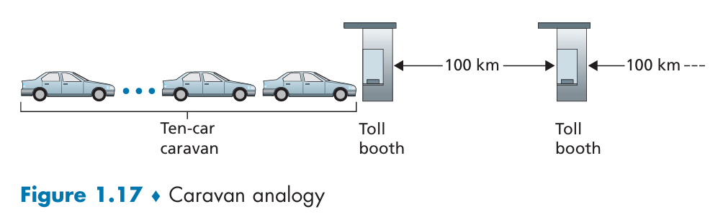
You can think of each car as a bit and the caravan as a packet. Also suppose that each tollbooth services (that is, transmits) a car at a rate of one car per 12 seconds. Finally, suppose that whenever the first car of the caravan arrives at a tollbooth, it waits at the entrance until the other nine cars have arrived and lined up behind it. (Thus, the entire caravan must be stored at the tollbooth before it can begin to be forwarded.)
The time required for the tollbooth to push the entire caravan onto the highway is:
Packet Transmission Delay = 12 seconds * 10 cars/bits = 120 seconds = 2 minutes
This time is analogous to the transmission delay in a router. The time required for a car to travel from the exit of one tollbooth to the next tollbooth is:
Packet Propagation Delay = 100 km/(100 km/hour) = 1 hour
This time is analogous to propagation delay. Therefore, the time from when the caravan is stored in front of a tollbooth until the caravan is stored in front of the next tollbooth is (the time it takes to transmit a packet from point A to point B):
Total Delay = transmission delay + propagation delay = 2 minutes + 1 hour = 62 minutes.

Suppose now that the cars travel at the rate of 1,000 km/hour (propagation speed) and the tollbooth services cars at the rate of one car (one bit) per minute (transmission rate). Then the traveling delay between two tollbooths is:
Packet Propagation Delay = 100km / (1000 km/hour) = 0.1 hour * 60 = 6 minutes
and the time to serve a caravan (packet) is:
Packet Transmission Delay = 10 cars * 1 minute = 10 minutes
In this case, the tollbooth service time for the caravan (packet) is greater than the time for a car (bit) to travel between toll booths. The first few cars in the caravan will arrive at the second tollbooth before the last cars in the caravan leave the first tollbooth. The first bits in a packet can arrive at a router while many of the remaining bits in the packet are still waiting to be transmitted by the preceding router.

Packet Queuing Delay and Packet Loss
Queuing delay is the time a packet waits in a buffer before being transmitted. It's the most variable of all network delays, changing from moment to moment depending on network congestion.
a) Suppose N packets arrive simultaneously to a link at which no packets are currently being transmitted or queued. Each packet is of length L and the link has transmission rate R. What is the average queuing delay for the N packets?
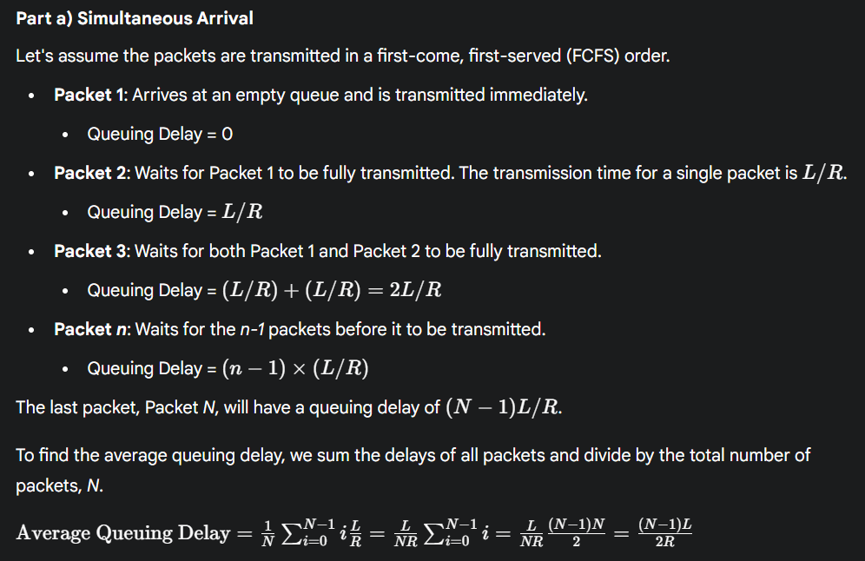
b) Now suppose that N such packets arrive to the link every LN/R seconds. What is the average queuing delay of a packet?
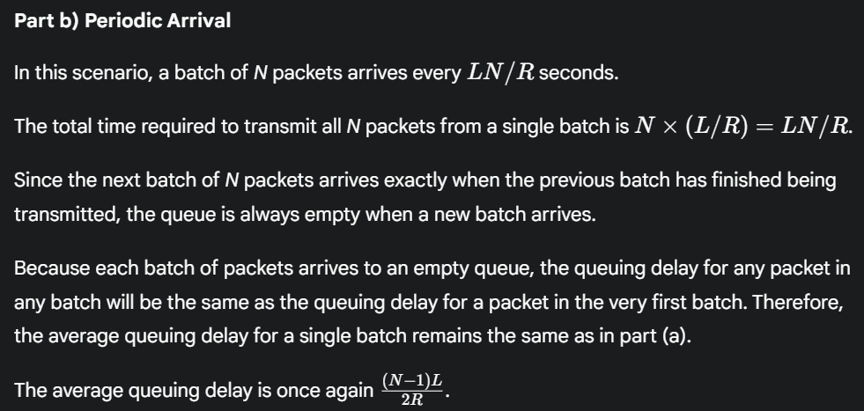

Traffic Intensity
The length of the queuing delay is primarily determined by the traffic intensity, which is the ratio of the average arrival rate of bits to the transmission rate of the link.
- a: average packet arrival rate (packets/sec)
- L: packet length (bits in a packet)
- R: link bandwidth or transmission rate (bits/sec))
the average arrival rate of bits is: Arrival Rate (packets/sec)*Packet Length=a×L=La
Traffic Intensity = Average Arrival Rate (bits/sec)​ / Transmission Rate (bits/second) = La / R​
- If Traffic Intensity is > 1: The arrival rate of data is faster than the transmission rate, queuing delay increase rapidly as traffic intensity approaches one. When greater than 1, the queue will grow indefinitely, and the queuing delay will approach infinity. This is an unstable and undesirable state for a network.
- If Traffic Intensity is < 1: The network is stable. Queuing delays are minimal when traffic is low (intensity near zero).

Case La/R <= 1: Here, the nature of the arriving traffic impacts the queuing delay. For example, if packets arrive periodically—that is,
- one packet arrives every L/R seconds,
then every packet will arrive at an empty queue and there will be no queuing delay.
On the other hand, if packets arrive in bursts but periodically, there can be a significant average queuing delay. For example, suppose
- N packets arrive simultaneously every N*(L/R) seconds
Then the first packet transmitted has no queuing delay; the second packet transmitted has a queuing delay of L/R seconds; and more generally, the nth packet transmitted has a queuing delay of (n-1)*L/R seconds.

If the traffic intensity is close to zero, then packet arrivals are few and far between and it is unlikely that an arriving packet will find another packet in the queue. Hence, the average queueing delay will be close to zero. On the other hand, when the traffic intensity is close to 1, there will be intervals of time when the arrival rate exceeds the transmission capacity (due to variations in packet arrival rate), and a queue will form during these periods of time; when the arrival rate is less than the transmission capacity, the length of the queue will shrink. Nonetheless, as the traffic intensity approaches 1, the average queue length gets larger and larger.
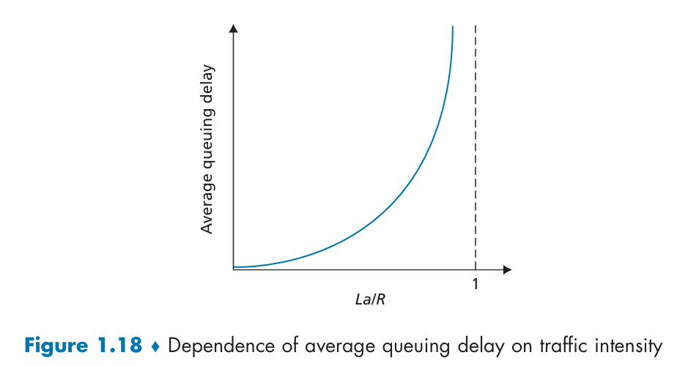

Packet Loss
Since all buffers have a finite capacity, a packet may arrive to find the queue completely full. When this happens, the router cannot store the packet and is forced to drop it. This is known as packet loss. The probability of packet loss increases as traffic intensity gets closer to 1.

End-to-End Delay
Total end-to-end delay is the sum of the four nodal delays—processing, queuing, transmission, and propagation—across every router and link in a packet's path. If a path has a source, a destination, and N−1 routers, the total delay is the sum of the delays at each of the N nodes.
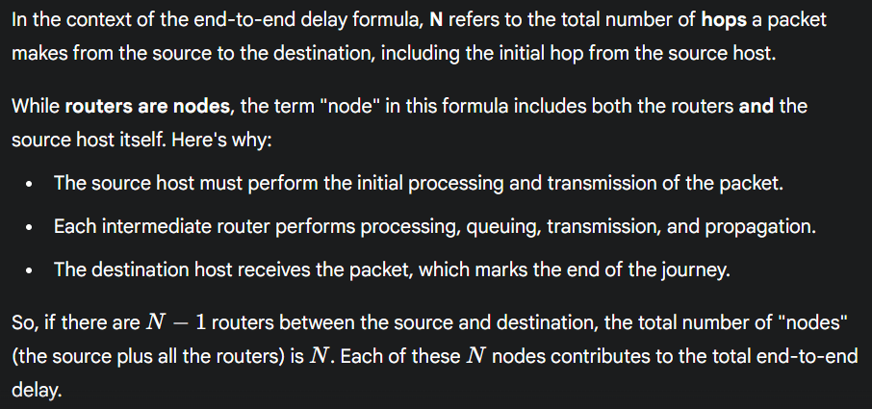
Traceroute
Traceroute is a diagnostic tool that measures the round-trip delay to each router along a path from a source to a destination.
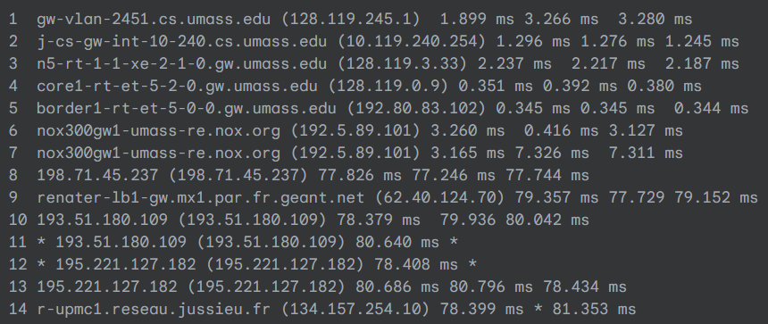
- How It Works: The source sends special packets to the destination. Each router on the path, from the first to the last, sends a message back to the source. The source records the time it takes to receive the reply from each router. If the source receives fewer than three messages from any given router (due to packet loss in the network), Traceroute places an asterisk just after the router number and reports fewer than three round-trip times for that router.
- What It Measures: The round-trip delays reported by Traceroute include all four types of nodal delays, offering a practical way to see delays on a live network. A significant jump in delay (like the one seen in the example from router 7 to 8) often indicates a long-distance link with a large propagation delay, such as a transatlantic cable.
Real Internet Delays & Routes
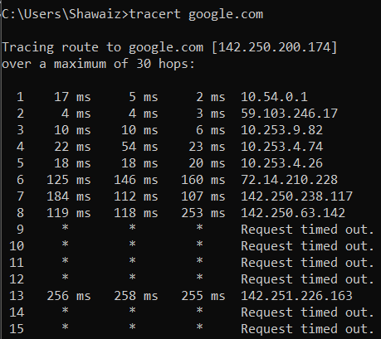
The output of a Traceroute command shows:
- The path: A list of all the routers (hops) that the packet passed through to get to its destination.
- Router information: The hostname and IP address of each router along the path.
- Round-trip delay: The time it takes for a packet to travel to each router and for the response to come back. This is typically measured three times for each hop to account for network variability. This round-trip delay is the total of all the delays a packet experiences on its journey to that router and back.
- Packet loss: If a router fails to respond, it is often indicated by an asterisk (*) in the output, its either the routers are configured not to respond to these specific packets, or there might be network congestion, or the packet was lost.
- Hops 1 through 8 and hop 13 received responses and show latency times (e.g., 1 17 ms 5 ms 2 ms).
- Hops 9, 10, 11, 12, 14, and 15 did not respond before the timeout, indicated by the asterisks (* * *). These are still counted as hops in the route, even though they are configured not to respond to the probe packets. So total hops are 15.

Throughput
Throughput is the rate at which data is successfully transferred from a source to a destination. There is both instantaneous throughput (the rate at a specific moment) and average throughput (total file size divided by total transfer time).
For a file of F bits transferred in T seconds, the average throughput is F/T bps.
The Bottleneck Link
The end-to-end throughput of a data transfer is limited by the bottleneck link. This is the link with the lowest transmission rate along the path.
- Formula: For a simple path with multiple links, the throughput is equal to the minimum of all the transmission rates. For a path with N links of rates R₁, R₂, ..., R_N, the throughput is: Throughput = min{R1, R2, ..., Rn}.
For example, if a file is being sent through two links with rates of 2 Mbps and 1 Mbps, the throughput will be 1 Mbps, limited by the slower link.
Shared Links
Throughput can also be affected by other traffic sharing the same link. A high-speed link can become a bottleneck if many other data flows are also using it. For example, if 10 users are sharing a 5 Mbps link, and the link's capacity is divided equally among them, each user would only get 500 kbps of throughput, regardless of their own access link speed.
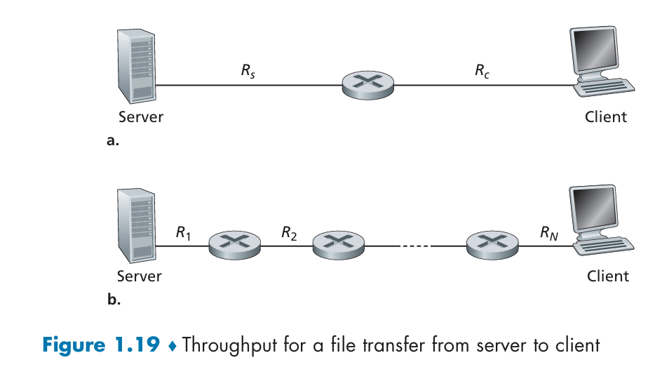
The server cannot pump bits through its link at a rate faster than Rs bps; and the router cannot forward bits at a rate faster than Rc bps. If Rs < Rc, then the bits pumped by the server will “flow” right through the router and arrive at the client at a rate of Rs bps, giving a throughput of Rs bps. If, on the other hand, Rc < Rs, then the router will not be able to forward bits as quickly as it receives them. In this case, bits will only leave the router at rate Rc, giving an end to-end throughput of Rc. (Note also that if bits continue to arrive at the router at rate Rs, and continue to leave the router at Rc, the backlog of bits at the router waiting for transmission to the client will grow and grow—a most undesirable situation!)
Example: Suppose that you are downloading an MP3 file of F = 32 million bits, the server has a transmission rate of Rs = 2 Mbps, and you have an access link of Rc = 1 Mbps. The time needed to transfer the file is then 32 seconds. The throughput is limited by Rc:
Throughput = min{Rs, Rc} = min{2 Mbps, 1 Mbps} = 1 Mbps
The transfer time is calculated as:
Time = File size / Throughput = 32 million bits / 1 Mbps = 32 million bits / 1,000,000 bits/sec = 32 seconds.
The rate at which bits can flow from source to destination is again the minimum of Rs and Rc, that is, throughput = min{Rs, Rc}. Therefore, the constraining factor for throughput in today’s Internet is typically the access network.

Bandwidth-Delay Product
The bandwidth-delay product is a fundamental concept in networking that represents the maximum number of bits that can be "in flight" or simultaneously on the network link at any given time.
The Formula
It is calculated by multiplying the link's transmission rate (bandwidth) by the propagation delay.
Bandwidth-Delay Product = Transmission Rate × Propagation Delay
- Transmission Rate: How fast bits are being pushed onto the link (in bits per second, bps).
- Propagation Delay: The time it takes for a single bit to travel from one end of the link to the other (in seconds).
This value is a measure of the "size" of the data pipe. Imagine a pipe with a certain flow rate and length. The bandwidth-delay product tells you the total volume of fluid that can be in that pipe at any moment.
How much data can be unacknowledged: In protocols that use pipelining, the sender can transmit up to the bandwidth-delay product of data before needing to receive an acknowledgment/response for the first bit sent.
Link utilization: A sender must have a window size at least as large as the bandwidth-delay product to keep the link fully utilized and achieve maximum throughput.

Pipeline
In computer networking, pipelining is a technique that allows a sender to transmit multiple packets back-to-back without waiting for a response for each one. It's a method to improve the efficiency of data transfer, especially over high-latency links. Pipelining is a technique where different stages of communication overlap in time.
Instead of waiting for one entire unit of data (like a file or packet) to be fully transmitted and received before starting the next, parts of the data are sent in a continuous stream.
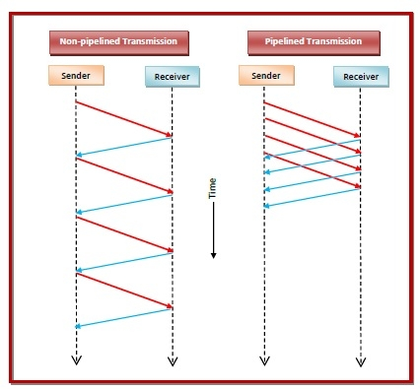
Without pipelining, a sender would have to follow a "stop-and-wait" protocol:
- Send a single packet.
- Wait for an ACK (acknowledgment/response) from the receiver.
- Only then, send the next packet.
On a long-distance link with high propagation delay, this is very inefficient. The sender spends a lot of time idle, waiting for ACKs to arrive. Without pipelining (store-and-forward of the whole file), every intermediate router must receive the entire file before forwarding.
Pipelining allows the sender to fill the network "pipeline" by transmitting packets continuously. It works like an assembly line:
- The sender transmits a stream of packets.
- The receiver receives them in order and sends back cumulative ACKs (acknowledging multiple packets at once) or selective ACKs.
- The sender keeps a window of unacknowledged packets. As ACKs arrive, the window slides forward, allowing new packets to be sent.
With pipelining, data is broken into packets, and as soon as one packet is received, it can be forwarded while the sender continues transmitting the next packet.
This approach keeps the communication link busy and significantly increases the overall throughput by eliminating the idle time that is inherent in stop-and-wait protocols. The amount of data that can be "in flight" at any given time is determined by the bandwidth-delay product.

Numerical
A 20 MB file must be sent across 3 serial links with store-and-forward switching:
- Link 1: 10 Mbps, 500 km, propagation speed 2.5×10^8 times m/s
- Link 2: 5 Mbps, 800 km, propagation speed 2.5×10^8 times m/s
- Link 3: 50 Mbps, 1200 km, propagation speed 3.0×10^8 times m/s
Tasks:
a. Calculate transmission delay and propagation delay per link.
b. Find the total end-to-end delay (ignore queueing/processing).
c. If packets are 1 KB each, estimate how store-and-forward inflates total delay.
d. Using the bandwidth–delay product, determine how many bits can be “in flight” on Link 2.
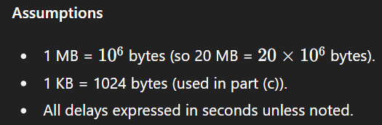
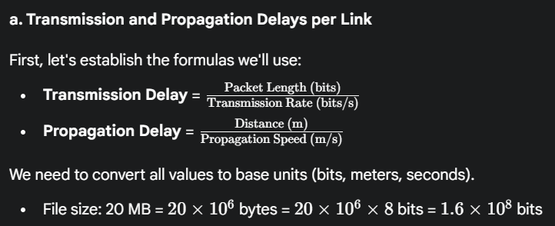
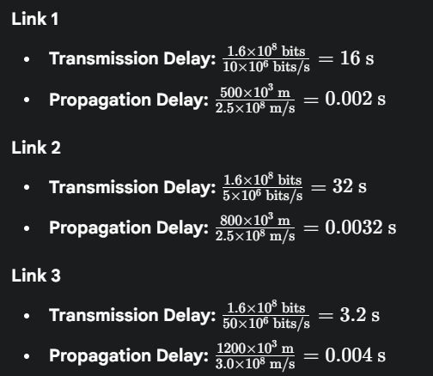
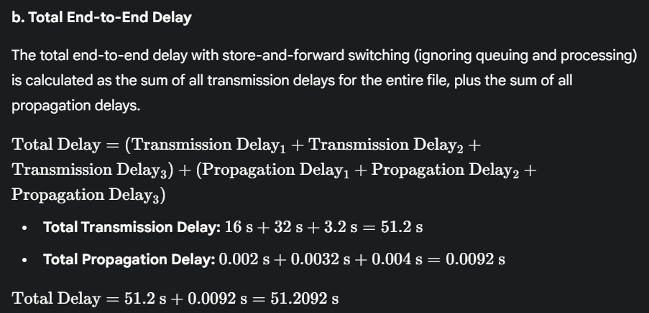
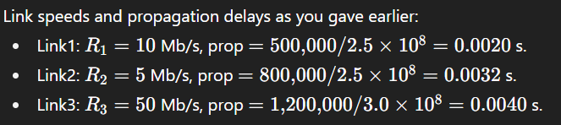
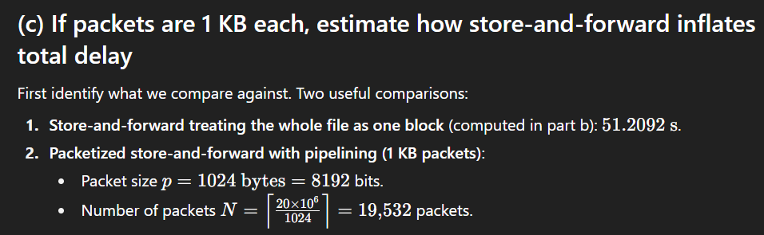

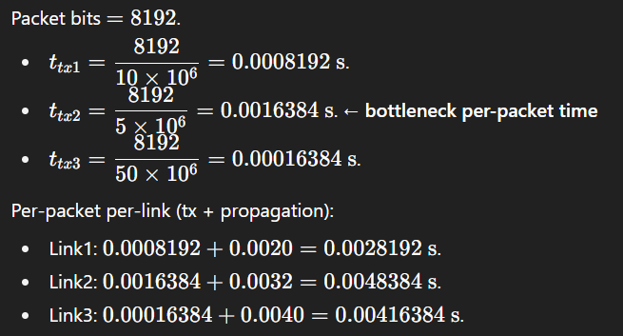
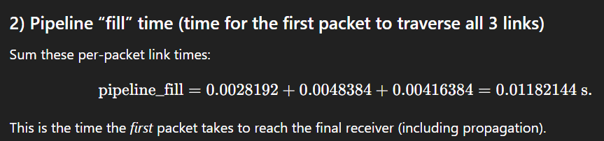
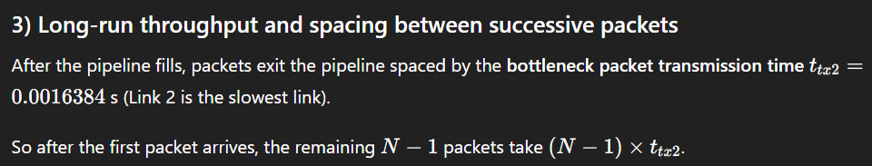
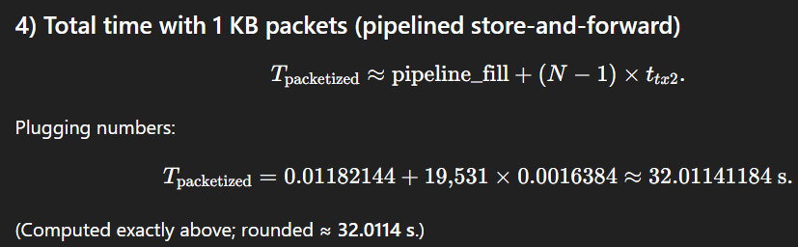
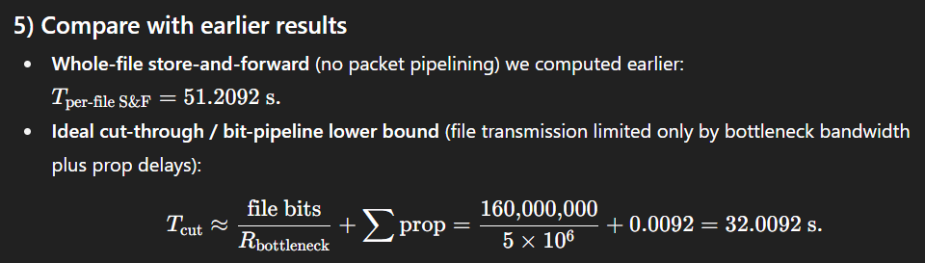
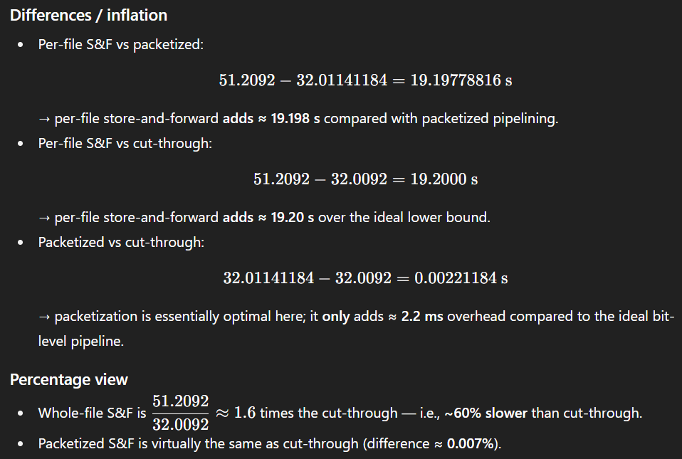
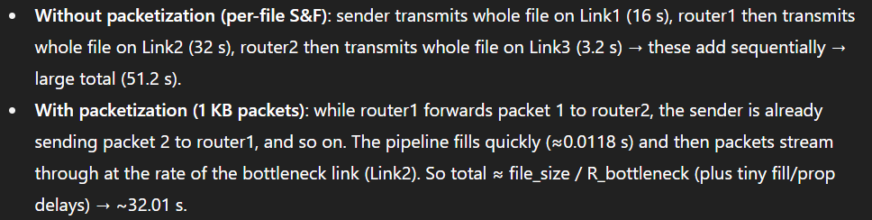

Networks Security

Packet Sniffing
A packet sniffer is a passive tool that records a copy of every packet traveling over a network.
How It Works and Where It's Used
Packet sniffers exploit the nature of network broadcasts. They are a major security vulnerability in wireless networks, where packets are transmitted over the air and can be easily intercepted by anyone with a receiver. In wired networks, sniffers can also be a threat if an attacker gains access to a shared broadcast link (like in some Ethernet or cable LANs) or an organization's router.
The Dangers
Because packets can contain sensitive data like passwords, credit card numbers, and personal messages, a packet sniffer can be used to capture this private information. Since these tools are passive—they only listen and do not send out any data—they are extremely difficult to detect. The best defense against packet sniffing is cryptography, which encrypts the data so that even if it is captured, it is unreadable.
A passive receiver that records a copy of every packet that flies by is called a packet sniffer. A bad guy who gains access to an institution’s access router or access link to the Internet may be able to plant a sniffer that makes a copy of every packet going to/from the organization. Packet sniffing software are free and open-source i.e WireShark.

IP Spoofing
IP spoofing is the act of creating and sending a packet with a false source IP address. This allows an attacker to masquerade/disguise as a trusted user or device. Because the Internet forwards packets based on their destination address without verifying the source, a receiver can be fooled into executing a command from a malicious sender. The solution to this vulnerability is end-point authentication, a security mechanism that verifies a message's origin.

Botnet
Malware is a broad term for malicious software that can be introduced into a host through the Internet. Once a host is infected, malware can delete files, steal sensitive information (spyware), and use the host for malicious activities without the user's knowledge.
Self-Replication and Botnets
Many types of malware are self-replicating, meaning they can spread from one host to another, often at an exponential rate. When malware infects thousands of hosts, it can form a botnet, a network of compromised devices controlled by an attacker. These botnets are often used to distribute spam or launch powerful Distributed Denial-of-Service (DDoS) attacks.

DDoS
Denial-of-Service (DoS) attacks aim to make a network service or host unusable for legitimate users. There are three main types:
- Vulnerability Attack: An attacker sends a few specially crafted packets to a vulnerable application, causing it to crash or stop working.
- Bandwidth Flooding: The attacker overwhelms the target's access link with a massive number of packets, preventing legitimate traffic from getting through.
- Connection Flooding: The attacker establishes a huge number of bogus/fake connections, which bogs/slow down the host and prevents it from accepting new, legitimate connections.
A Distributed Denial-of-Service (DDoS) attack is a more powerful form of bandwidth flooding. Instead of using a single source, an attacker controls multiple compromised hosts (a botnet) to send a flood of traffic to the target simultaneously. This makes it much harder to detect and block the attack.
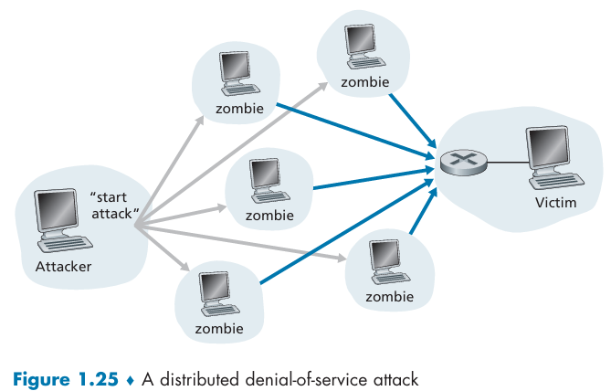

Line of Defence
There are several lines of defence against network security threats:
- Authentication: This proves that a user is who they claim to be. Cellular networks use a hardware identity, like a SIM card, for authentication, whereas traditional Internet connections often lack this feature.
- Confidentiality: This is achieved through encryption, which scrambles data to prevent unauthorized access.
- Integrity Checks: Digital signatures are used to detect and prevent any tampering with data during transmission.
- Access Restrictions: This involves using measures like password-protected VPNs (Virtual Private Networks) to control who can access a network.
- Firewalls: These are specialized security devices that act as filters for incoming and outgoing packets. They can be configured to block traffic from specific sources, to specific receivers, or for particular applications. They can also be used to detect and respond to Denial-of-Service (DoS) attacks.

Protocols
Protocols are the rules that defines the format and the order of messages exchanged between two or more communicating remote entities, as well as the actions taken on the transmission and/or receipt of a message or other event.
Protocols in routers determine a packet’s path from source to destination. Different protocols are used to accomplish different communication tasks.

Layered Architecture
Each layer provides a specific service by performing its own tasks and by relying on the services of the layer directly below it.
Why Layering is Important
Layering offers several key advantages for a complex system like the Internet:
- Modularity: It divides the complex system into smaller, more manageable components.
- Simplification: It allows you to focus on a single, well-defined part of the system.
- Flexibility: You can change the implementation of a layer's service without affecting the layers above or below it, as long as the service itself remains the same.
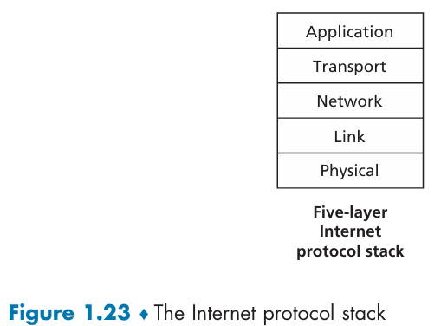

Network Protocol Stack
Here's a breakdown of some of the most fundamental protocols you'll encounter, they are categorized by their function within the TCP/IP model as layers.
1. Application Layer (Fifth)
These are the protocols that interact directly with the user and their applications. An application-layer protocol is distributed over multiple end systems, with the application in one end system using the protocol to exchange packets of information with the application in another end system. We’ll refer to this packet of information at the application layer as a message.
- HTTP (Hypertext Transfer Protocol): The foundation of the World Wide Web. It's the protocol used by web browsers to request and display web pages. HTTPS is the secure version of HTTP, which uses encryption to protect data.
- FTP (File Transfer Protocol): Used to transfer files between a client and a server. It's often used for uploading or downloading large files.
- SMTP (Simple Mail Transfer Protocol): The standard protocol for sending email. It's used by mail clients to send messages to a mail server.
- DNS (Domain Name System): A crucial protocol that translates human-readable domain names (like google.com) into computer-friendly 32-bit IP addresses (like 142.250.191.46). It's often called the "phonebook of the internet."
This layer enables end systems to exchange data using application-layer messages.

2. Transport Layer (Fourth)
These protocols handle the end-to-end communication between two devices and manage the data flow. This is where you'll find the most critical protocols for internet traffic. It transports application messages between endpoints.
- TCP (Transmission Control Protocol): This is a connection-oriented and reliable protocol. Before sending data, TCP establishes a connection (a process called the "three-way handshake"). It guarantees that all packets will be delivered in the correct order and without errors. If a packet is lost, TCP re-sends it. This makes it ideal for applications that require accuracy, like file transfers, email, and web browsing (HTTP).
- UDP (User Datagram Protocol): This is a connectionless and unreliable protocol. It doesn't establish a connection or guarantee delivery. It just sends packets and hopes they arrive. This might sound bad, but it makes UDP much faster and more efficient than TCP. UDP is perfect for applications where speed is more important than perfect delivery, such as video streaming, online gaming, and voice calls (VoIP).

3. Network Layer (Third)
The Internet’s network layer is responsible for moving network-layer packets known as datagrams from one host to another. The Internet transport-layer protocol (TCP or UDP) in a source host passes a transport-layer segment and a destination address to the network layer, just as you would give the postal service a letter with a destination address. The network layer then provides the service of delivering the segment to the transport layer in the destination host. These protocols are responsible for logical addressing and routing data across different networks. The Internet’s network layer contains routing protocols that determine the routes that datagrams take between sources and destinations.
- IP (Internet Protocol): The core protocol of the internet. IP is responsible for addressing and routing packets from a source host to a destination host. Every device on a network must have a unique IP address. It defines the fields in the datagram as well as how the end systems and routers act on these fields. There are two main versions:
  - IPv4: The older, 32-bit addressing system (e.g., 192.168.1.1).
  - IPv6: The newer, 128-bit addressing system designed to accommodate the explosion of connected devices (e.g., 2001:0db8:85a3:0000:0000:8a2e:0370:7334).
Although the network layer contains both the IP protocol and numerous routing protocols, it is often simply referred to as the IP layer.

4. Link Layer (Second)
These protocols handle communication on a local network segment (LAN).
- Purpose: Moves a datagram over a single link from one node (host or router) to the next adjacent node.
- Function: The network layer passes the datagram down to the link layer at each node to be delivered to the next hop.
- Ethernet: The most common protocol for wired local area networks. It defines the rules for how data is transmitted over an Ethernet cable.
- Wi-Fi (802.11): A family of protocols for wireless local area networks. It defines how devices communicate wirelessly using radio waves.
- Term: Link-layer packets are called frames.
It relies on link-layer protocols like Ethernet or Wi-Fi, and it can provide reliable data transfer over a single link. A datagram may be handled by different link-layer protocols as it moves from link to link on its path.
To move a packet from one node (host or router) to the next node in the route, the network layer relies on the services of the link layer. In particular, at each node, the network layer passes the datagram down to the link layer, which delivers the datagram to the next node along the route. At this next node, the link layer passes the datagram up to the network layer.
The services provided by the link layer depend on the specific link-layer protocol that is employed over the link. For example, some link-layer protocols provide reliable delivery, from transmitting node, over one link, to receiving node. Note that this reliable delivery service is different from the reliable delivery service of TCP, which provides reliable delivery from one end system to another.

5. Physical Layer (First)
The physical layer's job is to move the individual bits of a frame from one node to the next adjacent node. The protocols at this layer depend on the physical medium, such as copper wire or fiber optics, and determine how a bit is transmitted as a physical signal.
- Purpose: Moves the individual bits of a frame from one node to the next.
- Function: Responsible for the actual transmission of raw bits over the physical medium (e.g., copper wire, fiber, radio waves).
- Protocols: Dependent on both link technology and the transmission medium.
While the job of the link layer is to move entire frames from one network element to an adjacent network element, the job of the physical layer is to move the individual bits within the frame from one node to the next adjacent node.
The protocols in this layer are again link dependent and further depend on the actual transmission medium of the link (for example, twisted-pair copper wire, single-mode fiber optics). For example, Ethernet has many physical-layer protocols: one for twisted-pair copper wire, another for coaxial cable, another for fiber, and so on. In each case, a bit is moved across the link in a different way.

Encapsulation
Encapsulation is the process of adding headers (and sometimes trailers) to data as it moves down the protocol stack on the sending host. Each layer wraps the data it receives from the layer above in its own protocol-specific information before passing it down. This information is crucial for the receiving device to correctly process the data as it moves back up its own protocol stack.
The Postal Analogy: Sending a Letter
Imagine sending a sealed letter through the postal system:
- The Letter (Application Data): You write the content (the actual message or data).
- The Envelope (Transport Layer): You put the letter in an envelope and write the port numbers (like "Air Mail" or "Confidential"). This specifies how the letter should be handled.
- Addressing (Network Layer): You put the envelope in a postal bag and write the IP addresses (the source and destination street addresses). This defines where it's going across the entire network.
- Next-Hop Instructions (Link Layer): The postal worker puts a label on the bag for the MAC address (e.g., "For the Chicago Sorting Facility"). This defines the very next stop on the journey.
- Physical Delivery (Physical Layer): The bag is loaded onto a bit stream (a truck) and driven down the highway (the physical cable).
At each step, the previous package is encapsulated inside a new one with new instructions.
The Technical Process: Down the Protocol Stack
- Application Layer (5): Your original message (the data) is created. The application layer adds its own header to the message. This header contains information specific to the application protocol (e.g., HTTP).
- Transport Layer (4): The transport layer takes the message and its application header, and encapsulates it within a new segment with its own header. This header contains port numbers and information about flow control and reliability (for TCP).
- Network Layer (3): The transport segment is passed down to the network layer, which encapsulates it in a datagram (or packet). This layer adds an IP header that includes the source and destination IP addresses.
- Link Layer (2): The datagram is then encapsulated within a frame by the link layer. This frame adds its own header and a trailer, which contain the MAC addresses of the adjacent nodes and error-checking information.
- Physical Layer (1): Finally, the complete frame is converted into a stream of bits for transmission over the physical medium (e.g., fiber optic cable, wireless signal).
At the receiving end, the process is reversed, known as decapsulation or de-encapsulation. Each layer processes its own header, strips it away, and passes the remaining data up to the layer above it, until the original message is delivered to the application. This layered approach ensures that each layer only needs to understand its own header, making the network architecture modular and flexible.
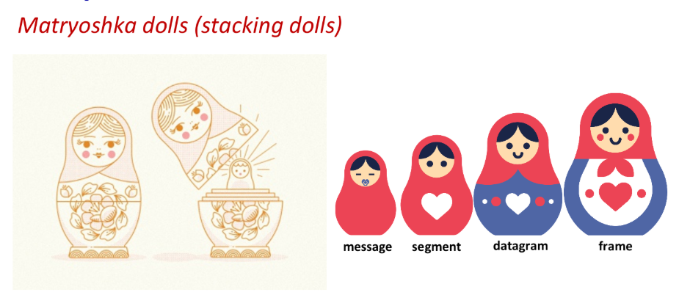
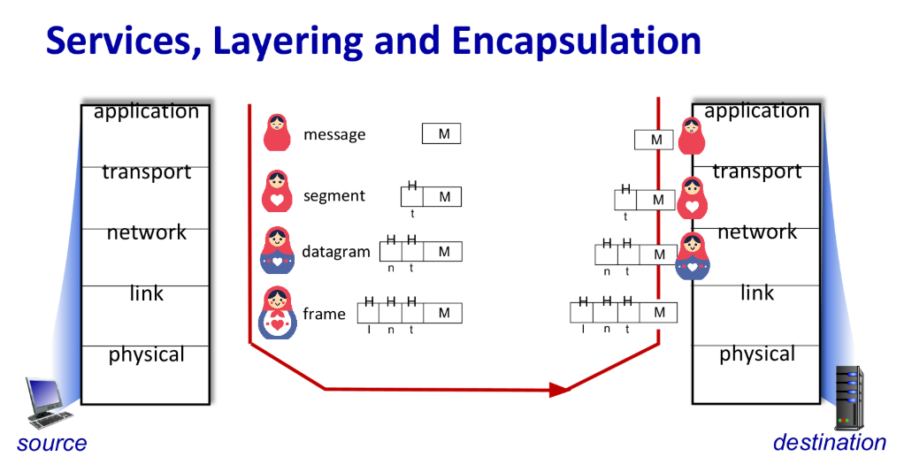
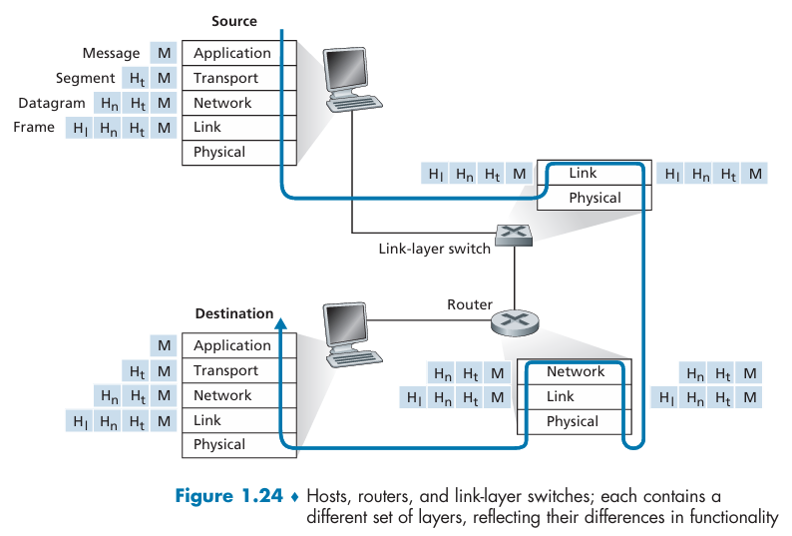
How Data Flows: Encapsulation & De-encapsulation
- Encapsulation (Down the Stack - Sending):
  - Data starts at the Application layer.
  - As it moves down each layer, a header (and sometimes a trailer at Layer 2) is added. This header contains control information for the corresponding layer on the receiving device.
  - This process of adding headers is called encapsulation.
- De-encapsulation (Up the Stack - Receiving):
  - The physical layer receives the raw bit stream and passes it up.
  - As the data moves up each layer, the corresponding header is read, acted upon, and then removed.
  - By the time it reaches the Application layer, the original data is presented to the user's application.

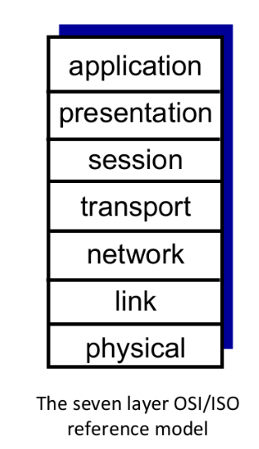
ISO/OSI Model
The Open Systems Interconnection (OSI) model is a theoretical/conceptual framework used to understand and standardize the functions of a telecommunication or computing system into seven distinct layers. While the Internet's protocol stack is a simplified five-layer model, the OSI model is a more comprehensive and widely used teaching tool for understanding networking concepts. It was developed by the International Organization for Standardization (ISO) in the 1980s to promote interoperability between diverse communication systems.
The seven layer protocol stack of the OSI model are:
- Application Layer (7): This is the top layer, where end-user applications and their protocols (like HTTP, FTP, and SMTP) operate. It provides the interface for the user to interact with the network.
- Presentation Layer (6): Deals with data representation and format. It can handle encryption, decryption, compression, and other data transformations.
- Session Layer (5): Establishes, manages, and terminates connections (sessions) between applications. It handles synchronization and dialogue control (simplex, half-duplex, full-duplex).
- Transport Layer (4): Provides end-to-end communication services for applications, including reliability, flow control, and segmentation of data. TCP and UDP are the main protocols here.
- Network Layer (3): Manages addressing and routing of packets across multiple networks. IP (Internet Protocol) is the most well-known protocol at this layer.
- Data Link Layer (2): Responsible for moving frames of data from one adjacent node to another. It handles error detection and correction on the physical link.
- Physical Layer (1): Handles the raw bit stream over the physical medium (cables, wireless signals). It defines things like voltage levels, data rates, and physical connectors.
Each layer in the OSI model communicates with the layer directly below it, and each layer adds its own header to the data as it's passed down the stack (encapsulation). On the receiving end, the process is reversed. While the OSI model is more theoretical, it provides a valuable way to break down and understand the complex interactions within a network.

